**Transparency in Financial Fraud Detection Using Explainable AI**

***A Project Report submitted***

***in partial fulfillment of the requirements***

***for the award of the degree of***

**BACHELOR OF TECHNOLOGY**

***In***

**COMPUTER SCIENCE & ENGINEERING**

***By***

1. KOMMULA LAKSHMI DEEKSHITHA - 21B01A0581

2. KARANAM SATYA VENKATA MANI SOWMYA - 21B01A0571

3. LALITHA SRI CHALAMALASETTI - 21B01A0589

4. MALLIPUDI LAKSHMI PRASANTHI - 21B01A0594

5. NALLURI SAMHITHA - 21B01A05B6

***Under the esteemed guidance of***

**Dr. V. Purushothama Raju Ph.D.**

**Professor**



**DEPARTMENT OF COMPUTER SCIENCE & ENGINEERING**

**SHRI VISHNU ENGINEERING COLLEGE FOR WOMEN(A)**

**(Approved by AICTE, Accredited by NBA & NAAC, Affiliated to JNTU Kakinada)**

**BHIMAVARAM – 534 202**

**2024 – 2025**

**SHRI VISHNU ENGINEERING COLLEGE FOR WOMEN(A)**

**(Approved by AICTE, Accredited by NBA & NAAC, Affiliated to JNTU Kakinada)**

**BHIMAVARAM – 534 202**

**DEPARTMENT OF COMPUTER SCIENCE & ENGINEERING**



**CERTIFICATE**

*This is to certify that the project entitled “****Transparency in Financial Fraud Detection Using Explainable AI****”, is being submitted by* ***Kommula Deekshitha, Karanam Sowmya, Lalitha Sri Chalamalasetti, Mallipudi Lakshmi Prasanthi, Nalluri Samhitha*** *bearing* *the Regd.No’s.* ***21B01A0581, 21B01A0571,21B01A0589,21B05A0594,21B01A05B6*** *in partial fulfillment of the requirements for the award of the degree of “****Bachelor of Technology*** *in* ***Computer Science & Engineering****” is a record of Bonafide work carried out by her under my guidance and supervision during the academic year 2024–2025 and it has been found worthy of acceptance according to the requirements of the university.*

**Internal Guide Head of the Department**

# External Examiner

# ACKNOWLEDGEMENTS

The satisfaction and euphoria that accompany the successful completion of any task would be incomplete without acknowledging the people who made it possible, whose constant guidance and encouragement crowned our efforts with success.

We wish to place our deep sense of gratitude to **Sri. K. V. Vishnu Raju, Chairman of SVES**, for his constant support in each and every progressive work of mine.

We wish to express our sincere thanks to **Dr. P. Srinivasa Raju, Director-Student Affairs & Admin for SVES - Bhimavaram,** for his constant support and encouragement.

We wish to express our sincere thanks to **Dr. G. Srinivasa Rao, Principal of SVECW**,for being a source of inspiration and constant encouragement.

We wish to express our sincere thanks to **Prof. P. Venkata Rama Raju**, **Vice-Principal of SVECW,** for his constant support and encouragement.

We wish to express our deep sense of gratitude to **Dr. P. Kiran Sree, Head of the Department of Computer Science and Engineering**, for his valuable advices in completing this project successfully.

We are deeply thankful to our project coordinator, **Dr. P. R. Sudha Rani, Professor**, for her indispensable guidance and unwavering support throughout our project completion. Her expertise and dedication have been invaluable to our success.

We wish to express our sincere thanks to our PRC members **Dr. A. Seenu**, **Mr.** **Y. Ramu,** **and** **Dr. T. Gayathri**, for their invaluable advices in successfully completing this project.

We sincerely thank our guide, **Dr. V. Purushothama Raju, Professor**, **Department of Computer Science and Engineering**, for providing his valuable suggestions and guidance throughout our project.

Project Associates:

1. K. Deekshitha (21B01A0581)
2. K. Sowmya (21B01A0571)
3. Lalitha. Ch (21B01A0589)
4. M. Prasanthi (21B01A0594)
5. N. Samhitha (21B01A05B6)

**ABSTRACT**

In the digital age, financial fraud has become increasingly complex, necessitating the use of advanced artificial intelligence (AI) and machine learning (ML) techniques for accurate detection. This system enables users to register, log in, and predict whether a transaction is fraudulent or legitimate using state-of-the-art ML models, including Logistic Regression, KNN, Decision Tree, Random Forest, XGBoost, SVM and Neural Network approach. Random Forest leverages multiple decision trees to enhance stability and reduce overfitting, while XGBoost, a highly efficient gradient boosting algorithm, ensures superior performance in classification tasks. By leveraging these models, the system provides a robust and scalable fraud prevention mechanism, helping users and organizations mitigate financial risks effectively.

One of the biggest challenges in AI-driven fraud detection is the lack of transparency, often making it difficult to interpret why certain transactions are flagged as fraudulent. To address this, the system integrates Explainable AI (XAI) techniques, ensuring interpretability in decision-making. SHAP (SHapley Additive Explanations) is employed to quantify the contribution of each feature to a prediction, providing clear insights into how factors like transaction amount, location, and time influence fraud classification. LIME (Local Interpretable Model-Agnostic Explanations) further enhances interpretability by perturbing input data and analyzing model responses, creating a simplified explanation for individual predictions. By importing SHAP and LIME, the system generates visual plots for each ML model—Logistic Regression, KNN, Decision Tree, Random Forest, XGBoost, SVM and Neural Network—offering users a transparent view of fraud detection decisions. This approach not only strengthens trust in AI-based fraud prevention but also empowers financial analysts and administrators with the necessary insights to refine risk management strategies.

**CONTENTS**

**S. No** **Topic** **Page No**

1. Introduction 1
2. System Analysis 6
   1. Existing System 7
   2. Proposed System 8
   3. Feasibility Study 9
   4. Project Flow 11
3. System Requirements Specification 12
   1. Software Requirements 13
   2. Hardware Requirements 13
   3. Functional Requirements 13
   4. Non-functional Requirements 14
4. System Design 15
   1. Introduction 16
   2. UML Diagrams 17
   3. Database Design 22
      1. ER Diagrams 22
      2. Table Structures 23
5. System Implementation 25
   1. Introduction 26
   2. Project Modules 27
   3. Algorithms 31
   4. Screens 36
6. System Testing 43
   1. Introduction 44
   2. Testing Methods 45
   3. Test Cases 48
   4. Results 52
7. Conclusion 55
8. Bibliography 57
9. Appendix 60
   1. Project repository details 61
   2. Introduction to Python Programming 62
   3. Streamlit 67
   4. PostgreSQL 69
   5. Introduction to Explainable AI 70

1. **INTRODUCTION**
2. **INTRODUCTION**

The study embarks on an in-depth exploration of advanced fraud detection techniques in credit card transactions, focusing on machine learning models such as Random Forest, XGBoost, and an Ensemble model. The research aims to address the growing challenges of digital payment security by leveraging these models to improve accuracy, real-time detection, and adaptability to evolving fraudulent patterns. Fraudulent transactions have become increasingly sophisticated, making traditional rule-based detection methods inadequate in preventing financial crimes. This study seeks to overcome these limitations by integrating machine learning into a financial web application, providing a secure and efficient platform for managing digital transactions.

Random Forest, a powerful ensemble learning algorithm, is known for its ability to handle large datasets and detect complex fraud patterns. XGBoost, on the other hand, is optimized for high-performance predictive modelling, offering better accuracy and computational efficiency. The combination of these models within an Ensemble framework ensures a balanced approach, reducing false positives while enhancing fraud detection precision. By comparing the strengths and trade-offs of these models, this study evaluates their effectiveness in real-time fraud prevention and financial security applications.

To assess their real-world applicability, the research utilizes a dataset of credit card transactions containing both legitimate and fraudulent activities. The system continuously analyzes transaction behaviour, identifying suspicious patterns and blocking fraudulent transactions before they are processed. Authentication measures such as multi-factor authentication and biometric verification are incorporated to further strengthen user security. Additionally, Firebase is used for backend support, providing a secure database infrastructure to manage transaction records.

The study also explores the impact of explainable AI (XAI) techniques, such as SHAP (Shapley Additive Explanations) and LIME (Local Interpretable Model-agnostic Explanations), to enhance transparency in fraud detection decisions. By making machine learning models more interpretable, the system not only improves fraud prevention but also helps users and financial institutions understand the reasoning behind fraud alerts.

The findings of this research are expected to contribute significantly to the fields of financial security, digital payment systems, and fraud prevention. By improving fraud detection accuracy and speed, the system enhances user trust, reduces financial risks, and strengthens the overall security of online transactions. Additionally, by minimizing false positives, it ensures a seamless user experience, preventing unnecessary transaction declines.

Ultimately, this project aims to highlight the effectiveness of machine learning-based fraud detection while offering insights into how these technologies can be further refined for real-world financial applications. The integration of real-time fraud detection into mobile and digital payment systems has the potential to revolutionize financial security, ensuring safer and more reliable transactions in the digital economy. This research lays the foundation for future advancements in fraud prevention, with applications extending beyond credit card transactions to other financial services and cybersecurity measures.

**1.1 OBJECTIVE OF PROJECT:**

The primary objective of this project is to develop an efficient fraud detection system for credit card transactions using advanced machine learning models such as Logistic Regression, KNN, Decision Tree, Random Forest, XGBoost, SVM and Neural Network. By leveraging these models, the system aims to enhance real-time fraud detection, improve accuracy, and adapt to evolving fraudulent patterns. Integrated into an financial web-application, it enables secure money transfers while continuously analyzing transaction data to identify suspicious activities. By comparing the performance of different machine learning models, the project seeks to determine the most effective fraud detection approach. Ultimately, this research contributes to strengthening digital payment security, reducing financial risks, and fostering trust in online transactions.

**1.2 PROBLEM STATEMENT:**

In the modern digital era, credit card fraud remains a significant concern for both users and financial institutions. As the frequency of online transactions increases, the challenge of ensuring secure and reliable financial activities becomes more pressing. Existing methods for detecting fraud in credit card transactions often face limitations in accuracy, real-time processing, and adaptability to new fraudulent patterns. In today's digital era, credit card fraud poses a significant risk to both users and financial institutions, with the increasing volume of online transactions making security and reliability more critical than ever. Traditional fraud detection methods often lack accuracy, real-time detection capabilities, and adaptability to evolving fraud techniques. Additionally, users often encounter difficulties in easily managing and transferring funds while ensuring security. This leads to a lack of trust in digital financial systems. Therefore, the problem addressed by this application is to create a secure and efficient platform for credit card transactions, integrating advanced fraud detection methods through machine learning, while providing a seamless user experience for managing funds and making transfers.

**1.3 MOTIVATION:**

**1. Improving Fraud Detection Accuracy:** Traditional fraud detection methods often struggle with accuracy, real-time processing, and adaptability to new fraud patterns. By leveraging advanced machine learning models like Logistic Regression, KNN, Decision Tree, Random Forest, XGBoost, SVM and Neural Network, this research aims to enhance fraud detection capabilities with greater precision and reliability.

**2. Ensuring Real-Time Fraud Prevention:** Delayed fraud detection can lead to significant financial losses. This study focuses on developing a real-time fraud prevention system that instantly identifies and blocks fraudulent transactions before they are completed, reducing the impact of cyber threats.

**3. Reducing False Alarms:** Many fraud detection systems generate high false-positive rates, flagging legitimate transactions as fraudulent. This can be frustrating for users, leading to unnecessary transaction declines and disruptions. By using machine learning models that improve detection precision, this project aims to reduce false positives while ensuring real fraud is accurately identified and stopped.

**4. Leveraging Technological Innovations:** The fields of artificial intelligence (AI) and machine learning have seen remarkable advancements in recent years, particularly in financial fraud detection. This research aims to harness these technologies to build a highly efficient, adaptable, and scalable fraud detection system that can be integrated into modern financial applications.

**1.4 SCOPE:**

**1. Model Evaluation**: The primary scope involves a detailed assessment of machine learning models Logistic Regression, KNN, Decision Tree, Random Forest, XGBoost, SVM and Neural Network models in terms of their detection speed, accuracy, and reliability when applied to financial fraud detection. This includes analysing how well each model performs under different conditions, such as location, phone number, credit card limit, email, session time, income.

**2. Dataset Utilization:** Utilizing a comprehensive dataset of credit card transactions featuring various transaction details across different settings and situations. The scope includes the collection, preparation, and augmentation of this dataset to ensure it effectively challenges the models and provides a robust basis for comparison.

**3. Performance Metrics:** The study focuses on quantifying the models' performance using standard metrics such as precision, recall, and the speed of detection. These metrics will help in understanding the trade-offs between speed and accuracy for real-time applications.

**2. SYSTEM ANALYSIS**

**2. SYSTEM ANALYSIS**

**2.1 EXISTING SYSTEM:**

The existing system for credit card transaction management primarily focuses on handling payments and transfers between users. Typically, these systems rely on centralized databases and conventional fraud detection algorithms to manage and monitor transactions. Authentication methods such as password-based login and basic encryption are often employed to safeguard user data. However, many of these systems face limitations in detecting fraudulent transactions in real-time due to their reliance on rule-based models, which can be easily bypassed by sophisticated fraud tactics. Fraud detection systems in existing platforms may not always leverage machine learning to dynamically learn from transaction data, resulting in false positives or undetected fraud attempts. Furthermore, the lack of real-time monitoring in some systems makes them vulnerable to financial crimes, as fraudulent activities may only be detected after significant losses occur.

**Disadvantages of the Existing System**

**1. Limited Fraud Detection Capabilities:** Traditional Fraud Detection methods often rely on rule-based methods or simplistic methods that can be bypassed by advanced fraud tactics. These systems lack the ability to adapt and learn from evolving patterns of fraudulent behaviour.

**2. High False Positive Rate:** Rule-based systems may generate a high number of false positives, flagging legitimate transactions as fraudulent, leading to user frustration and loss of trust in the system.

**3. Lack of real-time monitoring:** Existing systems may not provide real-time monitoring, allowing fraudulent transactions to go undetected for a longer time, leading to greater financial losses before detection.

**4. Limited Transparency and Accountability:** Transaction logs may not be securely stored or easily accessible, limiting transparency and accountability, and making it difficult to track fraudulent activities or resolve disputes.

**2.2 PROPOSED SYSTEM:**

The proposed system enhances credit card transaction fraud detection by leveraging advanced machine learning models, including Logistic Regression, KNN, Decision Tree, Random Forest, XGBoost, SVM and Neural Network, alongside Explainable AI (XAI) techniques. Logistic Regression, KNN, Decision Tree, Random Forest, XGBoost, SVM and Neural Network, improves accuracy, excels at handling complex data patterns and large-scale datasets. The Ensemble Model combines both to further improve predictive performance and robustness. To ensure transparency and interpretability, the system incorporates SHAP (Shapley Additive Explanations) and LIME (Local Interpretable Model-agnostic Explanations), providing insights into the factors influencing fraud detection decisions. This enables users to understand why a transaction was flagged as fraudulent. The system supports real-time fraud detection, processing each transaction immediately to prevent fraudulent activities before they are completed. Additionally, robust authentication measures, such as multi-factor and biometric verification, safeguard user data, while a comprehensive transaction log ensures transparency. This combination of accurate fraud detection, real-time processing, and explainable AI creates a secure and trustworthy platform for managing credit card transactions.

**Advantages of the Proposed System**

Increased Efficiency and Speed: By utilizing MobileNet as the backbone architecture, the proposed system benefits from a lightweight and efficient design, significantly reducing the computational resources required for processing. This efficiency enables faster detection speeds, making the system suitable for real-time applications in different situations.

* **Enhanced fraud detection accuracy:** The system uses advanced machine learning models like Logistic Regression, KNN, Decision Tree, Random Forest, XGBoost, SVM and Neural Network to detect fraudulent transactions with high precision. By analyzing large volumes of transaction data, it can identify complex fraud patterns that traditional rule-based systems often miss.
* **Real-Time Fraud Prevention:** Unlike conventional fraud detection systems that identify fraud after transactions are completed, this system operates in real-time. It continuously monitors transactions and instantly flags or blocks suspicious activities before they are processed. This proactive approach helps prevent financial losses and enhances the overall security of digital transactions.
* **Reduced Overfitting Risk:** The efficiency and generalization capabilities of MobileNet, combined with the robust training and validation strategies employed in the proposed system, minimize the risk of overfitting. This ensures that the system remains effective across different underwater settings and conditions.
* **Adaptive to Emerging Fraud Techniques:** Fraudsters continuously develop new tactics to bypass security measures, making static rule-based systems ineffective. The proposed system uses machine learning algorithms that continuously learn from historical transaction data and adapt to evolving fraud patterns. This dynamic learning capability allows the system to stay ahead of fraudsters, improving its long-term effectiveness. As new threats emerge, the model updates itself to recognize and counteract them efficiently.
* **Secure and Scalable Backend Support:** The system integrates Firebase for backend support, ensuring secure data storage and efficient processing of transaction records. Firebase provides real-time database updates, ensuring seamless functionality for fraud detection and prevention.
* **Comprehensive Transaction Logging and Transparency:** The system maintains detailed transaction logs, allowing users and financial institutions to track and audit financial activities. This transparency helps in resolving disputes, investigating fraudulent transactions, and maintaining accountability. The logs also assist in improving fraud detection algorithms by providing valuable data for further analysis. With a well-documented transaction history, users can confidently manage their financial activities.

**2.3 FEASIBILITY STUDY:**

The feasibility of the project is analysed in this phase and business proposal is put forth with a very general plan for the project and some cost estimates. During system analysis the feasibility study of the proposed system is to be carried out. This is to ensure that the proposed system is not a burden to the company. For feasibility analysis, some understanding of the major requirements for the system is essential.

Three key considerations involved in the feasibility analysis are:

* Economic feasibility
* Technical feasibility
* Social feasibility

**Economic Feasibility**

This study is carried out to check the economic impact that the system will have on the organization. The amount of fund that the company can pour into the research and development of the system is limited. The expenditures must be justified. Thus the developed system as well within the budget and this was achieved because most of the technologies used are freely available. Only the customized products had to be purchased.

**Technical Feasibility**

This study is carried out to check the technical feasibility, that is, the technical requirements of the system. Any system developed must not have a high demand on the available technical resources. This will lead to high demands on the available technical resources. This will lead to high demands being placed on the client. The developed system must have a modest requirement, as only minimal or null changes are required for implementing this system.

**Social Feasibility**

The aspect of study is to check the level of acceptance of the system by the user. This includes the process of training the user to use the system efficiently. The user must not feel threatened by the system, instead must accept it as a necessity. The level of acceptance by the users solely depends on the methods that are employed to educate the user about the system and to make him familiar with it. His level of confidence must be raised so that he is also able to make some constructive criticism, which is welcomed, as he is the final user of the system.

**2.4 Project Flow:**

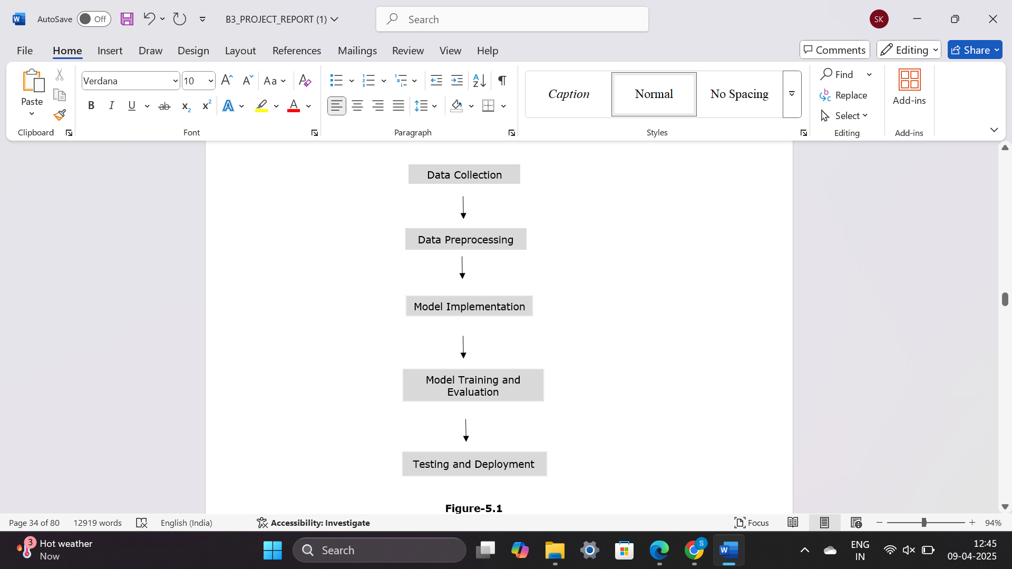

**Figure- 2.1: Project Flow**

**3. SYSTEM REQUIREMENTS SPECIFICATION**

**3. SYSTEM REQUIREMENTS SPECIFICATION**

This outlines the functional and non-functional requirements of a software system. It serves as a blueprint for developers, designers, and stakeholders to ensure everyone understands the project’s expectations. The SRS helps in minimizing misunderstandings and guides the development process effectively.

**3.1 SOFTWARE REQUIREMENTS:**

Operating System : Windows 10 or above

Programming Language : Python

Libraries : Pandas, Numpy, Matplotlib, OS, sklearn

IDE/Workbench : VSCode

Database : PostgreSQL

**3.2 HARDWARE REQUIREMENTS:**

Processor : Intel – I5

RAM : 8GB

Hard Disk : 512 GB

**3.3 FUNCTIONAL REQUIREMENTS:**

1. **User Authentication and Registration:** Users must be able to register and log in using secure authentication (e.g., username, password).
2. **Fraud Detection Using Machine Learning:** The system should analyze past transaction data to detect fraudulent activities. It must use machine learning models like Logistic Regression, KNN, Decision Tree, Random Forest, XGBoost, SVM and Neural Network to classify transactions as real or fraudulent.
3. **Explainable AI (XAI) Integration:** The system should use SHAP (Shapley Additive Explanations) and LIME (Local Interpretable Model-agnostic Explanations) to provide reasons for fraud detection decisions.

**3.4 NON-FUNCTIONAL REQUIREMENTS:**

1. **Performance and Efficiency:** The system must be optimized for high performance, reducing computational load to maintain efficiency in real-time scenarios.
2. **Scalability:** The architecture should allow for scalability, making it adaptable to varying volumes of data and allowing deployment on different hardware platforms.
3. **Energy Efficiency:** The system must conserve energy, particularly in battery-operated environments, to maximize operational time during underwater exploration.

**4. SYSTEM DESIGN**

**4. SYSTEM DESIGN**

**4.1 INTRODUCTION:**

**Input Design:**

In an information system, input is the raw data that is processed to produce output. During the input design, the developers must consider the input devices such as PC, MICR, OMR, etc.

Therefore, the quality of system input determines the quality of system output. Well-designed input forms and screens have following properties −

* It should serve specific purpose effectively such as storing, recording, and retrieving the information.
* It ensures proper completion with accuracy.
* It should be easy to fill and straightforward.
* It should focus on user’s attention, consistency, and simplicity.
* All these objectives are obtained using the knowledge of basic design principles regarding −
  + What are the inputs needed for the system?
  + How end users respond to different elements of forms and screens.

**Objectives of Input Design:**

The objectives of input design are −

* To design data entry and input procedures
* To reduce input volume
* To design source documents for data capture or devise other data capture methods
* To design input data records, data entry screens, user interface screens, etc.
* To use validation checks and develop effective input controls.

**Output Design:**

The design of output is the most important task of any system. During output design, developers identify the type of outputs needed, and consider the necessary output controls and prototype report layouts.

**Objectives of Output Design:**

The objectives of output design are:

* To develop output design that serves the intended purpose and eliminates the production of unwanted output.
* To develop the output design that meets the end user’s requirements.
* To deliver the appropriate quantity of output.
* To form the output in appropriate format and direct it to the right person.
* To make the output available on time for making good decisions.

**4.2 UML DIAGRAMS:**

**4.2.1 USE CASE DIAGRAM:**

A use case diagram in the Unified Modeling Language (UML) is a type of behavioral diagram defined by and created from a Use-case analysis. Its purpose is to present a graphical overview of the functionality provided by a system in terms of actors, their goals (represented as use cases), and any dependencies between those use cases. The main purpose of a use case diagram is to show what system functions are performed for which actor. Roles of the actors in the system can be depicted.

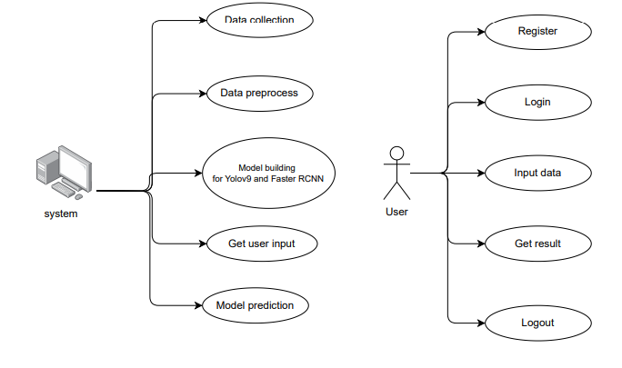

Admin

Model Building

**Figure – 4.1: Use Case diagram**

**4.2.2 SEQUENCE DIAGRAM:**

A sequence diagram in Unified Modeling Language (UML) is a kind of interaction diagram that shows how processes operate with one another and in what order. It is a construct of a Message Sequence Chart. Sequence diagrams are sometimes called event diagrams, event scenarios, and timing diagrams.

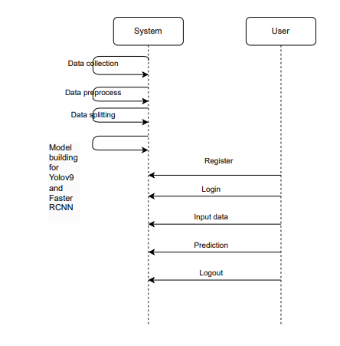

Model building (Random Forest, XGBoost and ensemble model)

**Figure – 4.2: Sequence diagram**

**4.2.3 COLLABORATION DIAGRAM:**

In collaboration diagram the method call sequence is indicated by some numbering technique as shown below. The number indicates how the methods are called one after another. We have taken the same order management system to describe the collaboration diagram. The method calls are similar to that of a sequence diagram. But the difference is that the sequence diagram does not describe the object organization whereas the collaboration diagram shows the object organization.

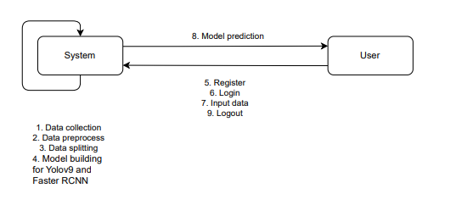

**Figure – 4.3: Collaboration diagram**

**4.2.4 DEPLOYMENT DIAGRAM**

Deployment diagram represents the deployment view of a system. It is related to the component diagram. Because the components are deployed using the deployment diagrams. A deployment diagram consists of nodes. Nodes are nothing but physical hardware’s used to deploy the application.

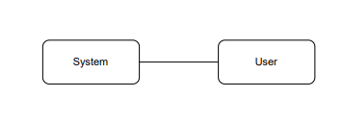

**Figure – 4.4: Deployment diagram**

**4.2.5 COMPONENT DIAGRAM**:

A component diagram, also known as a UML component diagram, describes the organization and wiring of the physical **c**omponents in a system.

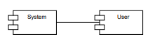

**Figure – 4.5: Component diagram**

**4.2.6 ACTIVITY DIAGRAM:**

Activity diagrams are graphical representations of workflows of stepwise activities and actions with support for choice, iteration and concurrency.

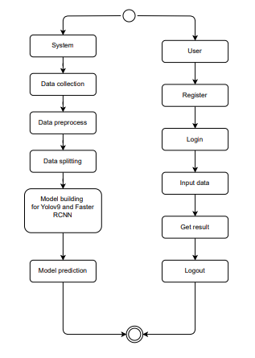

Model building

**Figure – 4.6: Activity diagram**

**4.3 DATABASE DESIGN**

**4.3.1 ER DIAGRAM**

An Entity–relationship model (ER model) describes the structure of a database with the help of a diagram, which is known as Entity Relationship Diagram (ER Diagram).

An ER diagram shows the relationship among entity sets. An entity set is a group of similar entities and these entities can have attributes.

In terms of DBMS, an entity is a table or attribute of a table in database, so by showing relationship among tables and their attributes, ER diagram shows the complete logical structure of a database.

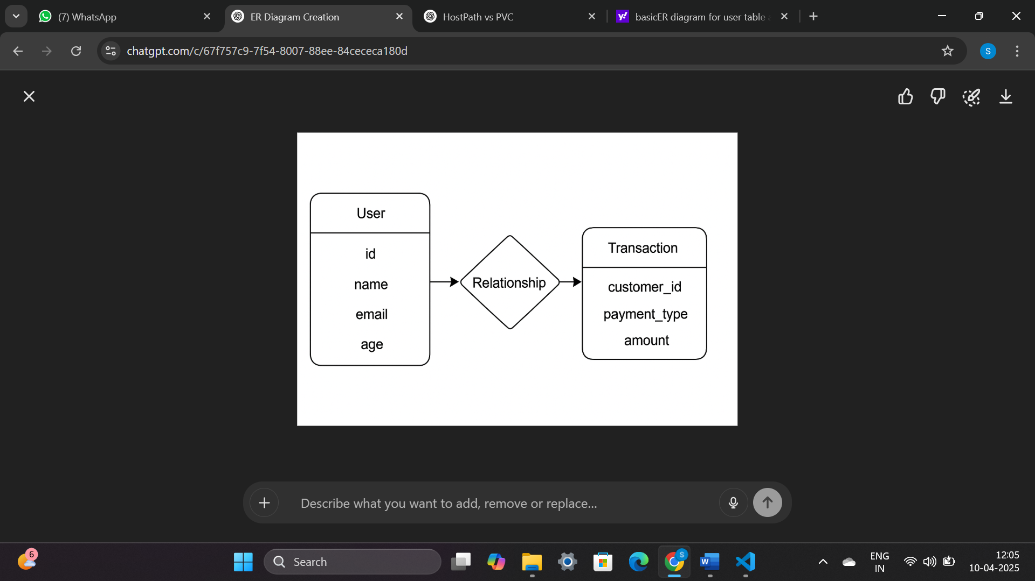

**Figure – 4.7: ER diagram**

**4.3.2 TABLE STRUCTURES**

**Users Table**

Purpose: The users table stores information about registered users, enabling authentication and access control.

**Table Schema:**

| **Column Name** | **Data Type** | **Constraints** | **Description** |
| --- | --- | --- | --- |
| id | INTEGER | PRIMARY KEY | Unique identifier for the customer |
| name | VARCHAR | NOT NULL | Full name of the customer |
| e-mail | VARCHAR(255) | UNIQUE, NOT NULL | User’s mobile number (used for login) |
| password | VARCHAR(255) | NOT NULL | User’s encrypted password |
| phone | VARCHAR | NOT NULL | Customer’s phone number |
| address | TEXT | NOT NULL | Residential address |
| income | |  | | --- | | NUMERIC |  |  | | --- | |  | | NOT NULL | Customer’s reported income |
| employment_status | VARCHAR | NOT NULL | Employment type (e.g., salaried, self-employed) |
| housing_status | VARCHAR | NOT NULL | Housing situation (e.g., owned, rented) |
| source | VARCHAR | NOT NULL | Source through which customer registered |
| dob | DATE | NOT NULL | |  | | --- | |  |  |  | | --- | | Date of birth | |
| created_at | TIMESTAMP | DEFAULT now() | Timestamp when profile was created |
| age | |  | | --- | | INTEGER |  |  | | --- | |  | | NOT NULL | Age of the customer |
| velocity_6h | |  | | --- | | INTEGER |  |  | | --- | |  | | NOT NULL | Number of applications in the past 6 hours |
| credit_risk_score | |  | | --- | | INTEGER |  |  | | --- | |  | | NOT NULL | Creditworthiness score |
| proposed_credit_limit | INTEGER | NOT NULL | System-proposed credit card limit |

**Table 4.8: Schema of the user’s table**

**Transactions Table**

Purpose: The transactions table stores individual financial transaction records made by users, including metadata used for fraud detection and analysis.

**Table Schema:**

| **Column Name** | **Data Type** | **Constraints** | **Description** |
| --- | --- | --- | --- |
| id | INTEGER | PRIMARY KEY | Unique identifier for the transaction |
| customer_id | INTEGER | NOT NULL | ID of the customer making the transaction |
| amount | DOUBLE PRECISION | NOT NULL | Amount involved in the transaction |
| prediction | VARCHAR | NOT NULL | Model prediction regarding transaction category |
| created_at | TIMESTAMP | DEFAULT NOW() | Timestamp of when the transaction occurred |
| payment_type | VARCHAR | NOT NULL | Mode of payment |

**Table 4.9: Schema of the transaction’s table**

**5. SYSTEM IMPLEMENTATION**

**5. SYSTEM IMPLEMENTATION**

**5.1 INTRODUCTION:**

The implementation phase involves putting the project plan into action. It is here where we should check whether the objectives of the project are met. The implementation phase is where we do the project work to produce the deliverables. The deliverables must include the products or services that the team are performing for the user including all the project management documents that you put together.

In our project, the user has to follow the below steps in order to use the application.

The steps are:

1. After successful entry to the home page, the user has to register in order to use the application.
2. Before registration the user can actually navigate to About section to understand many details about the application.
3. During the registration, the user has to specify credentials like name, email ID and password. The registration page is built with certain constraints like All the fields are mandatory, email ID must include “@”, both password and confirm password fields must match. If the user failed to meet the constraints, warnings will be generated.
4. Upon successful registration, the user has to login in order to proceed further. The login includes fields like mobile number and password. As soon as login is successful, the user can now access the application.
5. After login, the user can access different modules such as transaction initiation, fraud detection results, and logout.
6. Using the transaction module, the user can initiate a payment by entering the recipient’s details (mobile number or name) and transaction amount.
7. Before processing the transaction, the system performs fraud detection using machine learning models like Logistic Regression, KNN, Decision Tree, Random Forest, XGBoost, SVM and Neural Network. If fraud is detected. The system blocks the transaction and alerts the user. The user receives a notification with fraud risk details. If no fraud is detected, the transaction is processed successfully.
8. After processing the transaction, the user can view transaction history, where each transaction is labeled as legitimate, suspicious, or fraudulent.
9. At the end the user can freely logout from the system by clicking on logout module.

**5.2 PROJECT MODULES:**

The project modules include both system and user modules.

**5.2.1 System modules:**

**5.2.1.1 Fraud Detection:**

1. Collects input like transaction details such as amount, sender/receiver details, time, location, and past transaction records.
2. Clean and transform raw input data into model-ready features, such as transaction frequency, average amount, location deviation, and behavioral patterns.
3. Utilize Logistic Regression, KNN, Decision Tree, Random Forest, XGBoost, SVM and Neural Network analyze transaction data to detect fraudulent activities.

**5.2.1.2 Risk Classification & Fraud Prevention:**

1. Based on ML model predictions, transactions are classified as Legitimate, Suspicious, or Fraudulent.
2. If a transaction is flagged as fraudulent, it is immediately the transaction will be teriminated.

**5.2.2 User Modules:**

1. Register: Users must first register with their credentials to create an account in the system.
2. Login: Users can log in with their registered credentials to access the system and its features.
3. Initiate Transaction: Users can send money by entering the recipient’s details and transaction amount.
4. Viewing Transaction Results: User can see prediction where transactions are labeled as Safe, Suspicious, or Fraudulent, with detailed explanations.
5. Logout: Users can log out of the system to secure their session and personal data.

**Data Collection:**

The dataset used for this project is collected from Kaggle “Bank Account Fraud Dataset”. The dataset comprises a diverse collection of financial transaction records, specifically curated to detect fraudulent banking activities and enhance digital transaction security. It includes various transaction attributes such as transaction ID, user ID, transaction amount, location data, timestamp, and fraud labels (0 for legitimate, 1 for fraud). This dataset helps to make the model more versatile during training, ensuring accurate fraud detection and minimizing false positives and negatives. The dataset consists of 638,000 transactions, which are further split into 448,000 (70%) train, 127,000 (20%) validation, and 63,000 (10%) test samples.

**Data Preprocessing:**

* **Handling Missing Data:**

The dataset contains missing values that could affect fraud detection accuracy. Missing data is handled using **data imputation** techniques, such as replacing missing numerical values with the **mean or median** and categorical values with the **mode**. Transactions with critical missing data are removed to ensure model reliability.

* **Label Encoding for Categorical Features:**

Since machine learning models require numerical inputs, categorical transaction attributes (e.g., transaction type, location) are converted into numerical values using Label Encoding. This ensures the model correctly interprets categorical data.

* **Data Balancing with SMOTE:**

Fraud detection datasets are often imbalanced, with far fewer fraudulent transactions than legitimate ones. To address this, the Synthetic Minority Over-sampling Technique (SMOTE) is applied to generate synthetic fraud samples, balancing the dataset and preventing model bias toward non-fraudulent transactions.

* **Feature Scaling:**

To ensure all numerical features contribute equally to model training, MinMax Scaling is applied to normalize the transaction values between 0 and 1. This improves model efficiency and prevents features with larger values from dominating the training process.

* **Feature Selection:**

The most important transaction features are selected using Mutual Information (MI) and SelectKBest, which identify attributes that contribute the most to fraud detection. This reduces computational complexity while maintaining detection accuracy.

* **Train-Test Split:**

The dataset is split into 75% training and 25% testing to evaluate model performance on unseen transactions.

**Model Implementation:**

1. **Random Forest Implementation:** It combines multiple decision trees to improve fraud detection accuracy. It works by aggregating the predictions of multiple trees to classify transactions as fraudulent or legitimate. The model is implemented using Scikit-learn and trained on financial transaction data. Feature selection is performed to identify key fraud indicators, and hyperparameter tuning is applied to optimize performance. The model improves fraud detection by reducing overfitting and handling imbalanced datasets effectively.
2. **XGBoost Implementation:** It is a gradient boosting algorithm known for its high efficiency and ability to handle large datasets. It builds decision trees sequentially, improving predictions at each step by minimizing classification errors, the model is trained with fraud detection data, focusing on transaction anomalies such as unusual amounts, high transaction frequency, and location mismatches. The model is optimized using hyperparameters such as learning rate, max depth, and the number of estimators to enhance fraud classification accuracy.
3. **Logistic Regression Implementation:** It is a statistical model used for binary classification to predict the probability of a transaction being fraudulent or legitimate. The model is implemented using Scikit-learn and trained on financial transaction data. Key features are selected based on their correlation with fraud outcomes. The sigmoid function is used to map input features to probability scores. Hyperparameter tuning (like regularization strength) is applied to improve model generalization. Logistic Regression is effective for fraud detection due to its interpretability, efficiency, and ability to handle linearly separable patterns in data.
4. **K-Nearest Neighbors (KNN) Implementation:** It is a non-parametric, instance-based learning algorithm that classifies transactions based on the majority class among the *k* closest data points. The model is implemented using Scikit-learn and trained on financial transaction data. Feature scaling is applied to ensure distance calculations are accurate. Optimal value of *k* is determined through cross-validation to balance bias and variance. KNN enhances fraud detection by capturing local data patterns and identifying anomalies through proximity to known fraudulent or legitimate transactions.
5. **Support Vector Machine (SVM) Implementation:** It is a supervised learning algorithm used for binary classification by finding the optimal hyperplane that separates fraudulent and legitimate transactions. The model is implemented using Scikit-learn and trained on financial transaction data. Feature scaling is essential to ensure accurate margin calculations. Both linear and non-linear kernels (like RBF) are explored depending on data distribution. Hyperparameter tuning (e.g., C and gamma) is performed to optimize the decision boundary. SVM improves fraud detection by effectively handling high-dimensional data and outliers, and by maximizing the margin between classes.
6. **Neural Network Implementation:** It is a deep learning model inspired by the human brain, capable of learning complex, non-linear relationships in transaction data. The model is implemented using TensorFlow or Keras and trained on financial transaction datasets. It consists of input, hidden, and output layers with activation functions like ReLU and sigmoid. Feature scaling and normalization are applied to improve training efficiency. Hyperparameters such as the number of layers, neurons, learning rate, and batch size are tuned to enhance performance. Neural Networks improve fraud detection by capturing intricate patterns, adapting to evolving fraud behaviors, and handling imbalanced data through techniques like class weighting or oversampling.

**Model Training and Evaluation:**

**Model Training:** Training is a fundamental process in deep learning where the model gains knowledge from labelled data and make accurate predictions on unseen data. Training is necessary to enable the model to recognize patterns and associations within the data, allowing it to make informed decisions. During training, models learn to extract increasingly complex and meaningful features from raw input data, by iteratively transforming the data through multiple layers of non-linear transformations. In the context of financial fraud detection, training the models with a diverse dataset helps them to learn the features associated with different frauds. The models Logistic Regression, K-Nearest Neighbors (KNN), Decision Tree, Random Forest, XGBoost, Support Vector Machine (SVM), and Neural Networkare trained in the backend by using train dataset that has 638,000 transactions, which are further split into 448,000 (70%) train, 127,000 (20%) validation, and 63,000 (10%) test samples.

**Model Evaluation:** Once the 7 models are trained, their performances are evaluated based on metrics such as Training value, Precision, Recall, False Positives and False Negatives, mAP for detection accuracy, IOU for bounding box accuracy. Considering all the metrics Faster Random Forest is considered as the best model for detecting the financial fraud. So, in the front end, random forest is used for predicting the financial fraud.

**Testing and Deployment:**

The model is deployed and tested on various images to ensure that the system works well in any given environment. The system is tested by providing an image which is not given during training. The model will accurately identify the location of fish using anchor boxes or bounding boxes and the species will be classified with a confidence score.

**5.3 ALGORITHMS:**

* + 1. **Random Forest:**
* Random Forest is an **ensemble learning method** that builds multiple decision trees and combines their outputs to improve classification accuracy. It is highly effective in detecting fraud as it reduces overfitting and handles large transaction datasets efficiently.
* The algorithm is designed to handle high-dimensional data and detect fraud patterns across multiple transaction types. It can effectively identify

suspicious transactions, whether they involve small unauthorized transfers or large fraudulent withdrawals. This adaptability is crucial in real-time fraud detection environments.

* **Input Data**: The fraud detection process begins with transaction data, which undergoes preprocessing, including missing value handling, feature scaling, and encoding categorical variables.
* **Feature Extraction**: The model extracts key transaction features such as transaction amount, frequency, time of transaction, and location. These features are essential for identifying fraud patterns.
* **Model Training:** The Random Forest algorithm trains multiple decision trees using historical transaction data, where each tree independently classifies transactions as fraudulent or legitimate. The model aggregates these predictions to improve overall accuracy.
* **Fraud Prediction:** The trained model assigns a fraud probability score to each transaction. If the probability exceeds a predefined threshold, the transaction is flagged as suspicious or fraudulent.
* **Post-Processing:** After generating predictions, the system applies additional verification steps, such as manual review for high-risk transactions, ensuring accuracy before blocking or approving a transaction.
* **Output:** The final output includes a fraud risk score, classification label (fraudulent or legitimate), and transaction details. This information is displayed in the system's dashboard for visualization and further analysis.
  + 1. **XGBoost:**
* XGBoost employs a boosting framework that builds decision trees sequentially, where each new tree corrects the errors made by the previous ones. This structure enables high efficiency and improved predictive accuracy in fraud detection.
* The algorithm is designed to handle imbalanced datasets, making it highly effective in detecting fraudulent transactions, which are rare compared to legitimate transactions. By assigning higher weights to misclassified fraud cases, XGBoost improves its ability to identify complex fraud patterns.
* **Input Image:** The process begins with transaction data, which is preprocessed by handling missing values, normalizing numerical features
* **Feature Extraction:** XGBoost selects and ranks the most important features, such as transaction amount, transaction frequency, and location anomalies, ensuring the most relevant fraud indicators contribute to decision-making.
* **Model Training:** The algorithm iteratively builds decision trees, learning from previous errors, and adjusting feature importance to improve fraud classification. The process continues until the model reaches optimal accuracy.
* **Fraud Prediction:** The trained model generates a probability score for each transaction, determining whether it is legitimate or fraudulent based on a predefined threshold.
* **Output:** The final output includes a fraud probability score, classification label (fraudulent or legitimate), and risk level for further analysis and fraud prevention measures.
  + 1. **Logistic Regression:**
* Logistic Regression is a linear classification algorithm that predicts the probability of a transaction being fraudulent or legitimate using the sigmoid activation function. Its simplicity and interpretability make it a strong baseline model for fraud detection.
* It is well-suited for handling imbalanced datasets through class weighting or resampling techniques, ensuring that rare fraudulent transactions are not overlooked during training. Regularization (L1/L2) is applied to avoid overfitting and maintain model generalization.
* **Input Image:** The process begins with transaction data, which is preprocessed by handling missing values and standardizing or normalizing numerical features to ensure consistency.
* **Feature Extraction:** Logistic Regression identifies features with high predictive power, such as transaction amount, transaction frequency, merchant category, and time-based anomalies, using statistical methods like correlation analysis or univariate selection.
* **Model Training:** The model learns optimal weights for each feature by minimizing the log-loss function. Hyperparameters, particularly the regularization strength, are tuned using validation data to improve classification accuracy and robustness.
* **Fraud Prediction:** The trained model assigns a probability score to each transaction, indicating the likelihood of fraud. A threshold is applied to this score to classify the transaction as either fraudulent or legitimate.
* **Output:** The final output includes a fraud probability score, a binary classification label (fraudulent or legitimate), and the contribution of each feature to the prediction, providing transparency for further analysis and fraud risk assessment.
  + 1. **K-Nearest Neighbors (KNN):**
* K-Nearest Neighbors is a non-parametric, instance-based learning algorithm that classifies transactions based on the majority class among the *k* closest samples in the feature space. It relies on distance metrics (e.g., Euclidean) to find similar past transactions.
* KNN is capable of detecting localized fraud patterns by comparing new transactions with historical ones. It can handle imbalanced datasets when combined with distance-weighted voting or data balancing techniques.
* **Input Image:** The process begins with transaction data, which is preprocessed by handling missing values and applying feature scaling techniques such as Min-Max normalization or standardization to ensure accurate distance calculations.
* **Feature Extraction:** Relevant features, such as transaction amount, location, device ID, and time of transaction, are selected to effectively represent the behavior of transactions in the multi-dimensional space.
* **Model Training:** Unlike traditional models, KNN does not perform explicit training; instead, it stores the entire training dataset and performs classification at runtime by computing distances between test samples and stored data.
* **Fraud Prediction:** For a given transaction, the algorithm identifies the *k* nearest neighbors and uses majority voting to determine whether the transaction is fraudulent or legitimate. Weighted voting may also be used, giving more influence to closer neighbors.
* **Output:** The final output includes a classification label (fraudulent or legitimate), the distance scores of the nearest neighbors, and optionally, a confidence score based on the proportion of neighbors in the predicted class.
  + 1. **Decision Tree:**
* Decision Tree is a supervised learning algorithm that splits data into branches based on feature values, creating a tree-like structure to classify transactions as fraudulent or legitimate. It uses conditions in the form of "if-then" rules, making the model highly interpretable and easy to visualize.
* The model handles imbalanced datasets by adjusting class weights or using pruning techniques to prevent overfitting. It is capable of capturing non-linear patterns in transactional behavior that may indicate fraud.
* **Input Image:** The process starts with transaction data, where preprocessing includes handling missing values and encoding categorical variables into numerical format to support decision-making at each node.
* **Feature Extraction:** Important features such as transaction amount, merchant category, time of day, and customer ID are selected using techniques like Gini impurity or information gain, which guide the tree-building process.
* **Model Training:** The algorithm builds the tree by recursively splitting the dataset based on the feature that provides the best separation between fraudulent and legitimate transactions, continuing until a stopping condition is met or further splitting does not improve performance.
* **Fraud Prediction:** For a new transaction, the model traverses the tree from the root to a leaf node based on the feature values, arriving at a classification label that determines if the transaction is fraudulent or legitimate.
* **Output:** The final output includes a binary classification label, a confidence score based on the proportion of training samples at the leaf node, and a rule-based path explanation, providing transparency into the model’s decision.
  + 1. **Support Vector Machine (SVM):**
* Support Vector Machine is a supervised learning algorithm that classifies transactions by finding the optimal hyperplane that best separates fraudulent and legitimate transactions. It focuses on maximizing the margin between the classes, leading to improved generalization and robustness.
* SVM handles imbalanced datasets using class weighting or by adjusting the penalty parameter (C) to give more importance to minority class (fraudulent) samples. Non-linear fraud patterns are addressed using kernel functions such as Radial Basis Function (RBF).
* **Input Image:** The process begins with transaction data that is preprocessed by handling missing values, encoding categorical variables, and scaling features to ensure accurate distance and margin calculations.
* **Feature Extraction:** Important features such as transaction frequency, location anomalies, and device fingerprints are selected to define the multidimensional space in which the hyperplane will be constructed.
* **Model Training:** The algorithm identifies the optimal separating hyperplane by solving a convex optimization problem. The support vectors—data points closest to the decision boundary—play a critical role in defining the classification rule.
* **Fraud Prediction:** For each new transaction, the model computes its position relative to the hyperplane. Based on the result, it assigns a classification label (fraudulent or legitimate) with a confidence margin.
* **Output:** The final output includes a classification label, a decision function score indicating the distance from the hyperplane, and the most influential features (support vectors) that influenced the classification outcome.
  + 1. **Neural Network:**
* Neural Network is a deep learning model inspired by the structure of the human brain, capable of learning complex, non-linear patterns in transaction data for fraud detection. It consists of interconnected layers of neurons that transform input features through activation functions to make accurate predictions.
* The model effectively handles imbalanced datasets using techniques such as class weighting, SMOTE (Synthetic Minority Oversampling Technique), or custom loss functions. Its adaptive learning capabilities make it suitable for evolving fraud tactics.
* **Input Image:** The process begins with transaction data, which is preprocessed by filling missing values, encoding categorical variables, and scaling features to optimize learning across neural layers.
* **Feature Extraction:** Neural Networks automatically learn relevant patterns from raw features like transaction amount, customer behavior history, IP address, and merchant ID, reducing the need for manual feature engineering.
* **Model Training:** The training process involves forward propagation of inputs through the network, computation of loss, and backpropagation to update weights using optimizers like Adam or SGD. Hyperparameters such as learning rate, number of layers, and batch size are tuned to achieve optimal performance.
* **Fraud Prediction:** Once trained, the network processes each transaction and outputs a probability score indicating the likelihood of fraud. A classification threshold is applied to label the transaction as fraudulent or legitimate.
* **Output:** The final output includes a fraud probability score, binary classification label, and (optionally) explanations using model interpretability tools like SHAP or LIME to highlight feature contributions.

**5.4 SCREENS:**

**5.4.1 Landing Page**

This screen (Figure- 5.1) serves as the main landing page or home page of the fraud detection system. It introduces the platform's core functionality—leveraging deep learning for the accurate identification frauds. The page guides users to easily navigate different sections, such as registration, login, and identification.



**Figure- 5.1: Home page**

**5.4.2 Registration Page**

The registration page (Figure-5.2) allows users to create an account by providing their name, email, password, and confirmation password. This form is designed for easy user onboarding to the credit card fraud detection system**.**

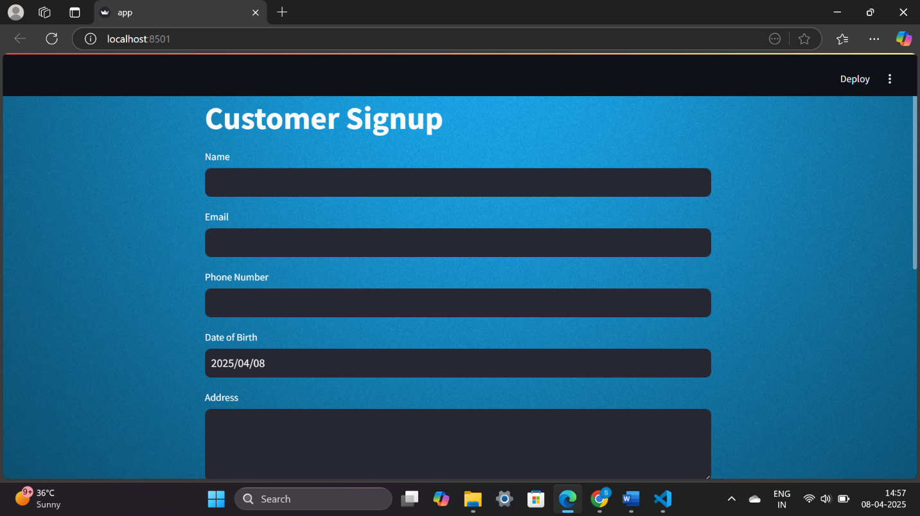

**Figure- 5.2: Registration page**

**5.4.3 Login Page**

The login page (Figure-5.3,5.4) provides users with a simple interface to access their accounts by entering their registered email and password. It ensures secure access to the system's functionalities.

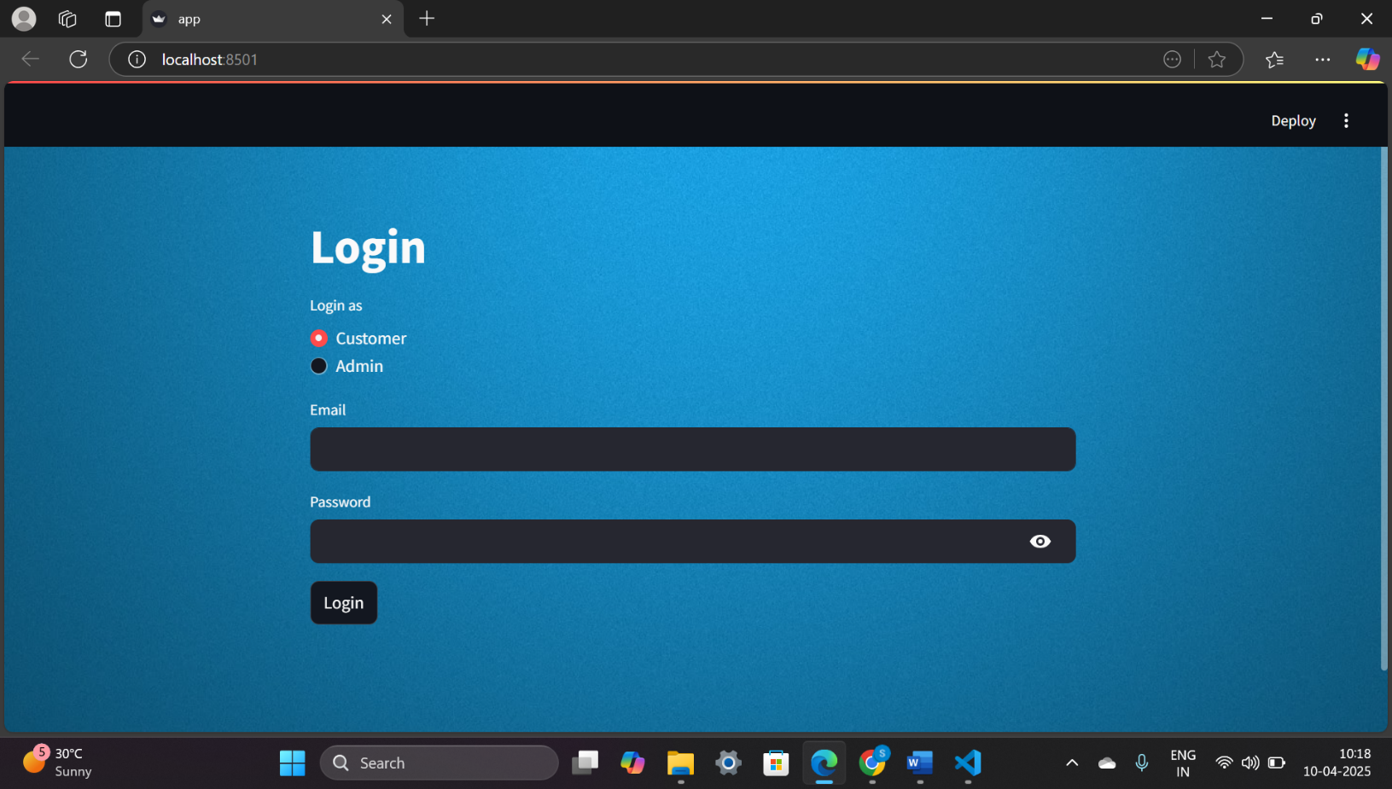

**Figure- 5.3: Customer login**

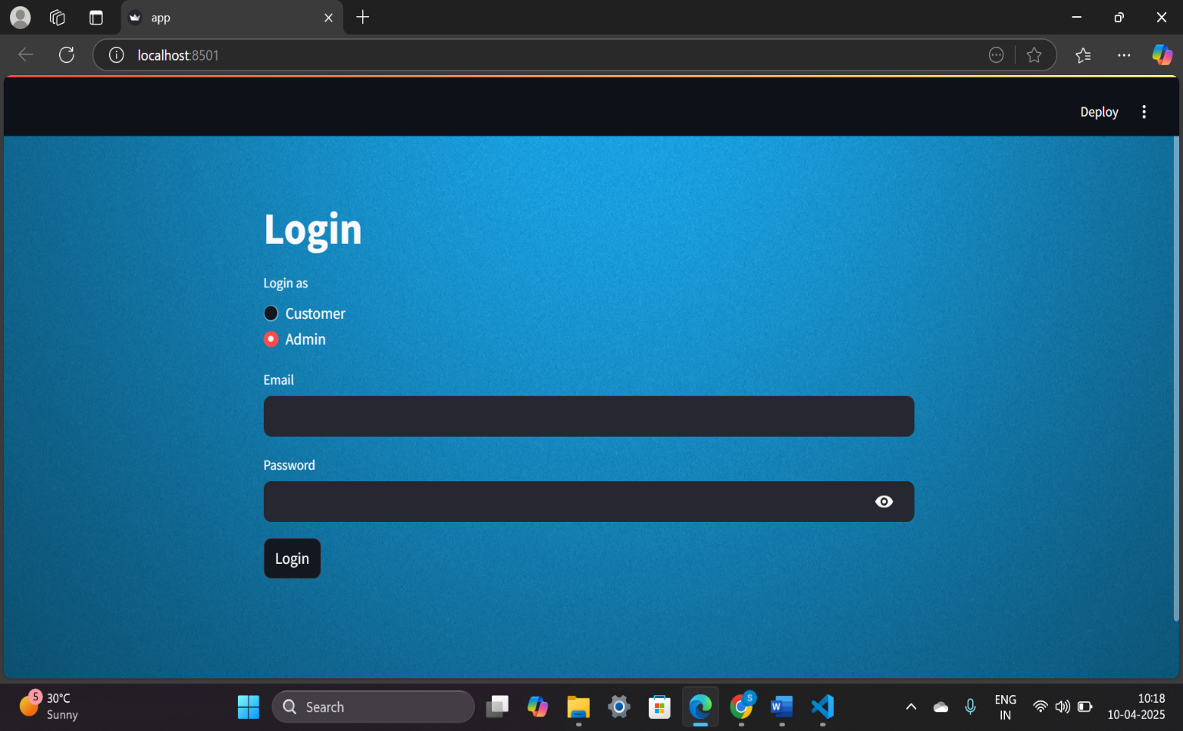

**Figure- 5.4: Admin login**

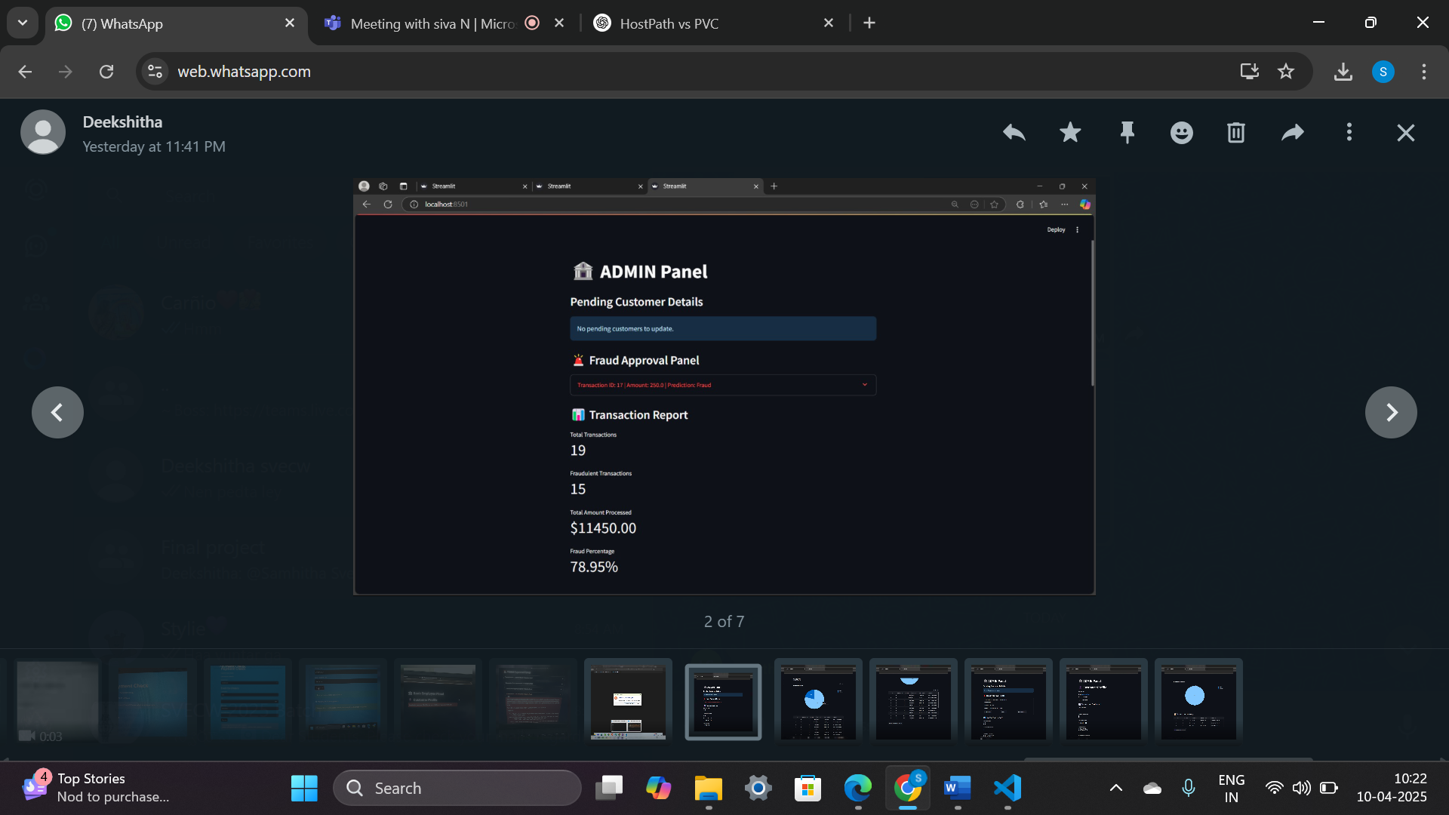

**Figure- 5.5: Admin portal**

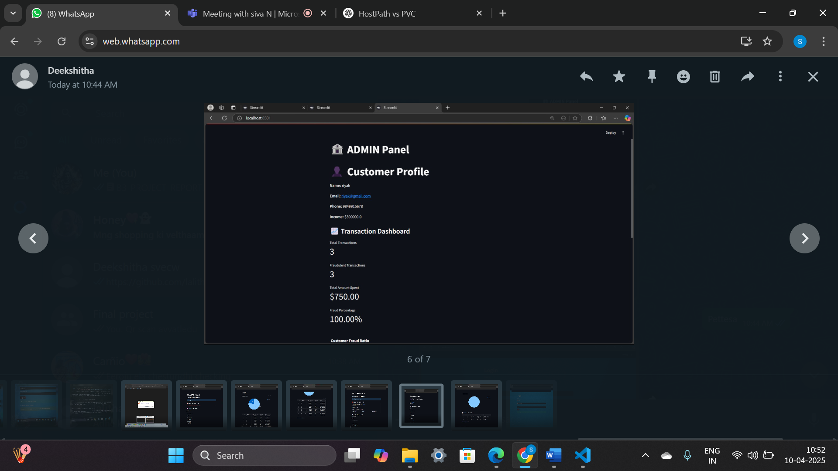

**Figure- 5.6: Admin portal (Customer Panel)**

The above page will be only visible to the admin where all the details of the fraud detection will be displayed.

**5.4.4 Products page**

The products page (Figure-5.7) welcomes users to the check for the products. It sets the stage for users to start interacting with the platform.

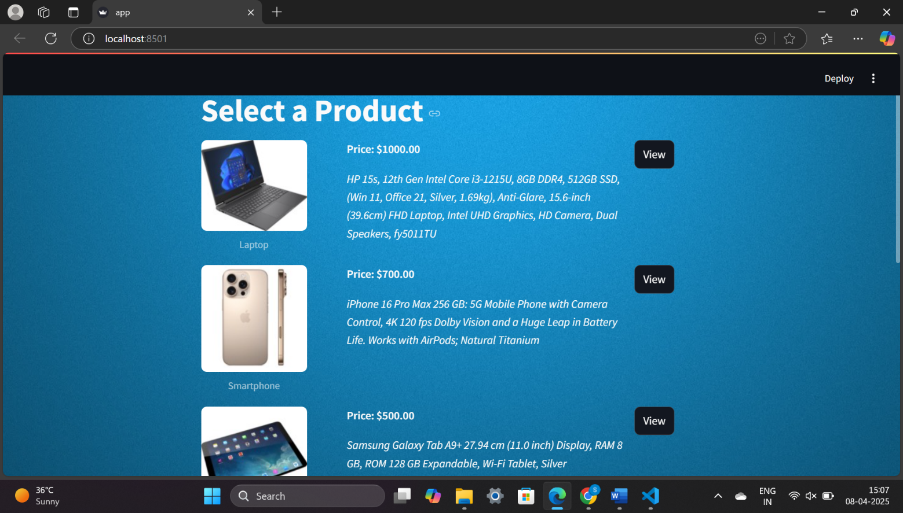

**Figure- 5.7: Products page**

**5.4.5 Product description page**

The product description page displays detailed information about a selected item, including image, price, specs.

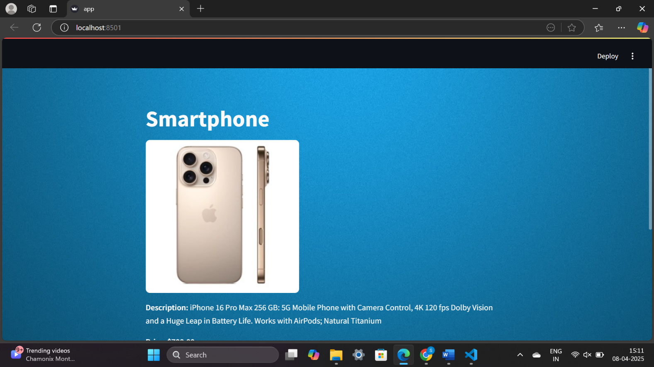



**Figure- 5.8: Product description page**

**5.4.6 Cart Page**

The cart page displays products added by the user, along with their quantities and prices. Users can update quantities, remove products, view the total amount, and proceed to checkout.

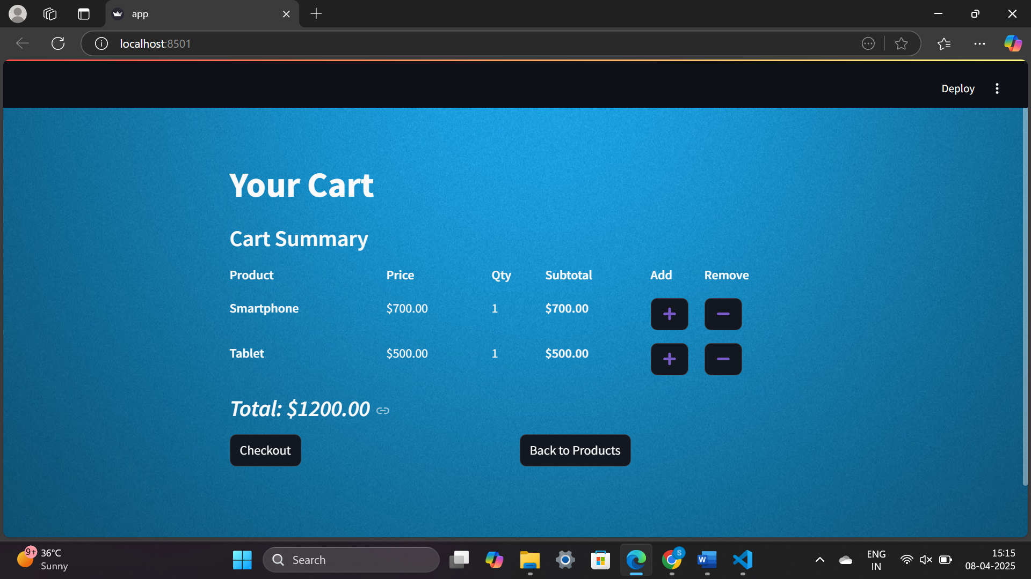

**Figure- 5.9: Cart page**

**5.4.7 Checkout Page**

The checkout page collects shipping and payment details from the user. It provides an order summary and allows the user to place the final order securely.

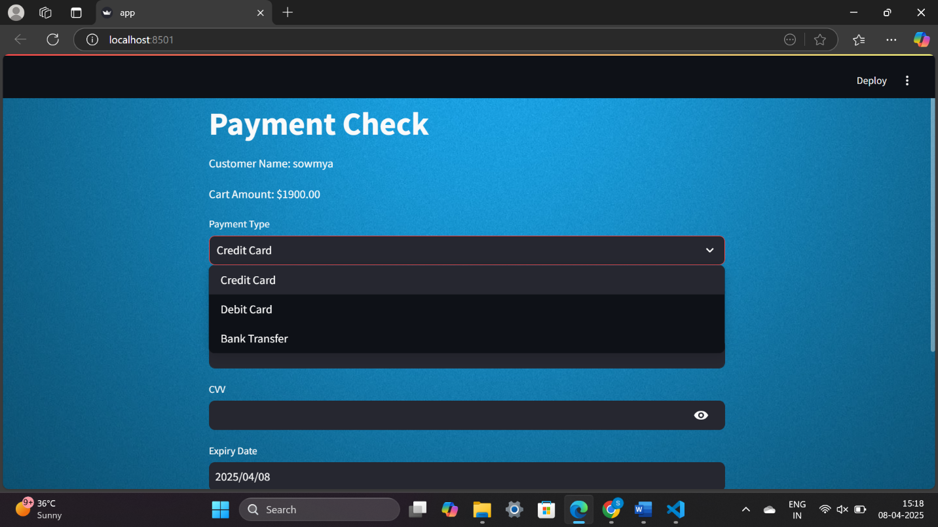

**Figure- 5.10: Checkout page**

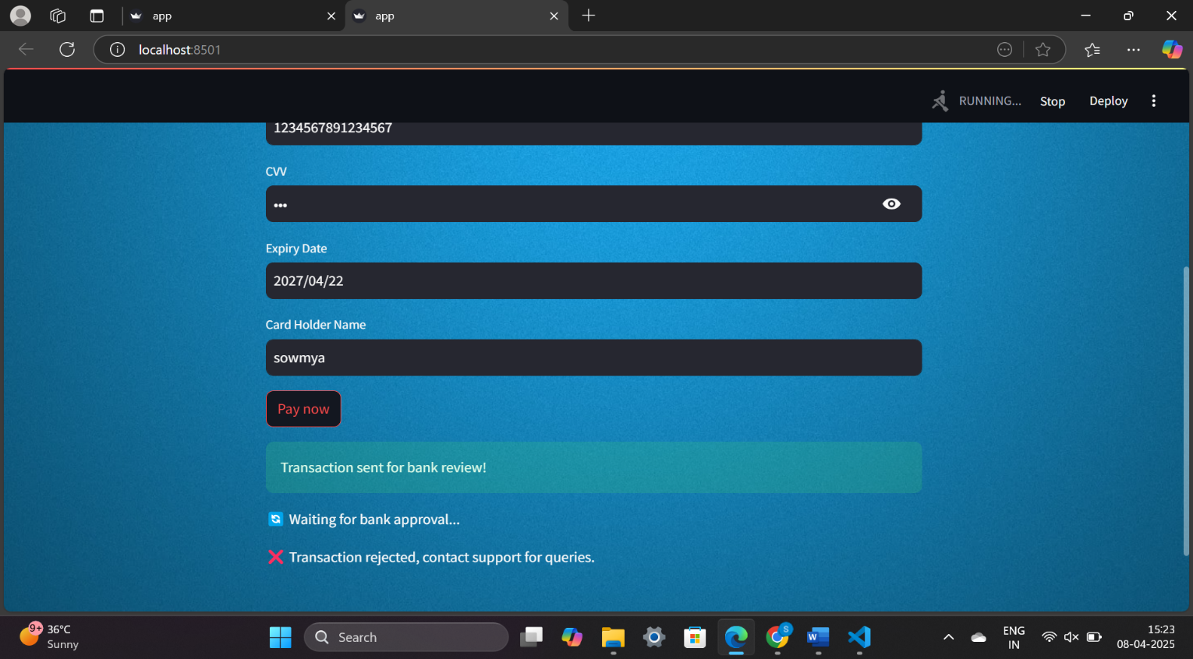

**Figure- 5.11: Checkout page**

The image shows a payment attempt where the user entered card details and clicked "Pay now". The transaction was initially sent for bank review, but later failed. A red error message — "Transaction rejected, contact support for queries." — indicates the payment was unsuccessful.

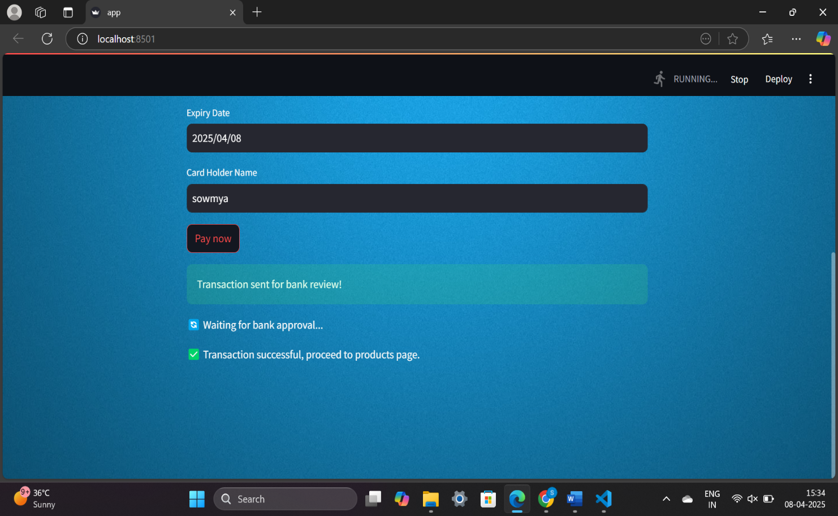

**Figure- 5.12: Transaction sent for bank review**

The image shows a payment page where the user entered valid card details and clicked "Pay now". A sequence of messages confirms the process: the transaction is sent for review, followed by bank approval. A final success message — "Transaction successful, proceed to products page." — confirms payment completion.

**6. SYSTEM TESTING**

**6. SYSTEM TESTING**

**6.1 INTRODUCTION:**

System Testing is a software testing phase where the entire system (software + hardware) is tested as a whole to ensure it meets the specified requirements. It is conducted after integration testing and before acceptance testing. System testing verifies that the application functions correctly across different environments, ensuring end-to-end validation of business requirements.

The purpose of testing is to discover errors. Testing is the process of trying to discover every conceivable fault or weakness in a work product. It provides a way to check the functionality of components, sub-assemblies, assemblies and/or a finished product It is the process of exercising software with the intent of ensuring that the software system meets its requirements and user expectations and does not fail in an unacceptable manner. There are various types of tests. Each test type addresses a specific testing requirement.

The objectives of system testing are:

* Verify that all integrated components function correctly.
* Ensure the system meets functional and non-functional requirements.
* Identify defects before deployment.
* Validate that the system works under real-world conditions.
* Test the system's interaction with external dependencies like databases, APIs, and other services.

The process of system testing is:

1. **Test Planning**

* Define test strategy, objectives, and scope.
* Identify required tools and test environments.
* Allocate resources and define schedules.

1. **Test Case Development**

* Create detailed test cases based on requirements.
* Prepare test data for various scenarios.

1. **Test Environment Setup**

* Configure hardware, software, network, and database.

1. **Test Execution**

* Run test cases and record results.
* Identify and log defects.

1. **Defect Tracking and Reporting**

* Report bugs and track their resolution.
* Retest fixes and perform regression testing.

1. **Test Closure**

* Prepare test summary reports.
* Review lessons learned for future improvements.

The benefits of system testing are:

1. Improves software quality, reliability, and security.

2. Reduce overall cost and time

3. Detects defects early.

4. Enhances user satisfaction by identifying usability issues.

**6.2 TESTING METHODS**

* + 1. **UNIT TESTING**

Unit Testing involves the design of test cases that validate that the internal program logic is functioning properly, and that program inputs produce valid outputs. All decision branches and internal code flow should be validated. It is the testing of individual software units of the application .it is done after the completion of an individual unit before integration. This is a structural testing, that relies on knowledge of its construction and is invasive. Unit tests perform basic tests at component level and test a specific business process, application, and/or system configuration. Unit tests ensure that each unique path of a business process performs accurately to the documented specifications and contains clearly defined inputs and expected results.

* + 1. **INTEGRATION TESTING**

Integration tests are designed to test integrated software components to determine if they actually run as one program. Testing is event driven and is more concerned with the basic outcome of screens or fields. Integration tests demonstrate that although the components were individually satisfaction, as shown by successfully unit testing, the combination of components is correct and consistent. Integration testing is specifically aimed at exposing the problems that arise from the combination of components.

Software integration testing is the incremental integration testing of two or more integrated software components on a single platform to produce failures caused by interface defects. The task of the integration test is to check that components or software applications interact without any error, e.g. components in a software system or one step up software applications at the company level.

* + 1. **ACCEPTANCE TESTING**

User acceptance Testing is a critical phase of any project and requires significant participation by the end user. It also ensures that the system meets the functional requirements.

* + 1. **FUNCTIONAL TESTING**

Functional tests provide systematic demonstrations that functions tested are available as specified by the business and technical requirements, system documentation, and user manuals.

Functional testing is centred on the following items:

Valid Input : identified classes of valid input must be accepted.

Invalid Input : identified classes of invalid input must be rejected.

Functions : identified functions must be exercised.

Output : identified classes of application outputs must be exercised.

Systems/Procedures : interfacing systems or procedures must be invoked.

Organization and preparation of functional tests is focused on requirements, key functions, or special test cases. In addition, systematic coverage pertaining to identify Business process flows; data fields, predefined processes, and successive processes must be considered for testing. Before functional testing is complete, additional tests are identified and the effective value of current tests is determined.

* + 1. **White Box Testing**

White Box Testing is a testing in which in which the software tester has knowledge of the inner workings, structure and language of the software, or at least its purpose. It is purpose. It is used to test areas that cannot be reached from a black box level.

* + 1. **Black Box Testing**

Black Box Testing is testing the software without any knowledge of the inner workings, structure or language of the module being tested. Black box tests, as most other kinds of tests, must be written from a definitive source document, such as specification or requirements document, such as specification or requirements document. It is a testing in which the software under test is treated, as a black box. you cannot “see” into it. The test provides inputs and responds to outputs without considering how the software works.

Test objectives

* All field entries must work properly.
* Pages must be activated from the identified link.
* The entry screen, messages and responses must not be delayed.

Features to be tested

* Verify that the entries are of the correct format
* No duplicate entries should be allowed
* All links should take the user to the correct page.

**6.3 TEST CASES**

**Registration Criteria:**

* In the registration page, user has to give his name, email id, create a password and confirm the password.
* The conditions that we have included are:

1. The email id should contain ‘@’.
2. The user has to fill all the fields.
3. The password and confirm password fields must match.
4. The user cannot register with the same email id more than once.

* The user must follow above criteria to register otherwise our system tries to give warning messages through which user can able to give correct data for registration.

**Login Criteria:**

* We have constructed our system login criteria in such a way that user must give proper data that he has given at the time of registration.
* If he gives any unmatched data our system raises warning messages and will not allow the user to proceed further.
* The conditions that we included are:

1. The email id and password during login, must be matched with the details given during registration.
2. Entering wrong password will terminate the login.
3. Entering an email id which is not registered will lead to warning messages.

**Validation Criteria:**

* The image which user uploads, will be given to the system.
* The system evaluates the given input image and based on features upon which it is trained, it will detect the location of the fish accurately using bounding boxes and also classifies the species of fish with a confidence score.

It shows the registration page with alert message. This alert will be raised when user tried to fill any invalid email address to register themself. By this alert they will get to know their error and can able to register with correct email address format next time. Here, for validating email we are taking some considerations: The format of the email i.e., the system validation function checks whether the email id that is given contains ’@’. If the email address fails the check, the function raises an error indicating that the email address is not valid. Otherwise, if it passes the check, the email address is considered valid.

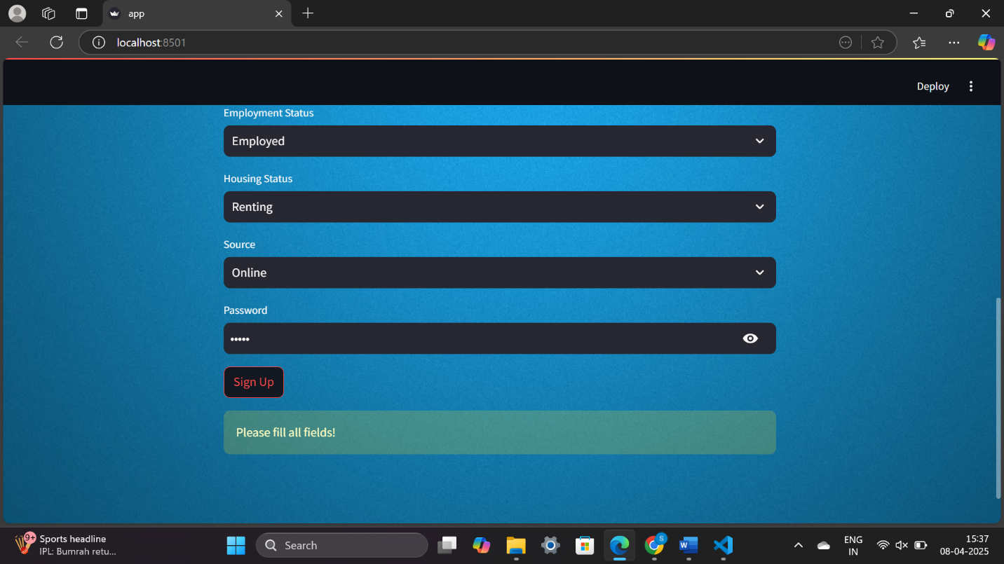

**Figure- 6.1: All fields are mandatory**

The above Figure- 6.1 indicates that during registration all the fields are mandatory to be filled. If a user did not fill any of the specified fields, the system will generate a warning otherwise the registration will be completed if all the necessary conditions are met.

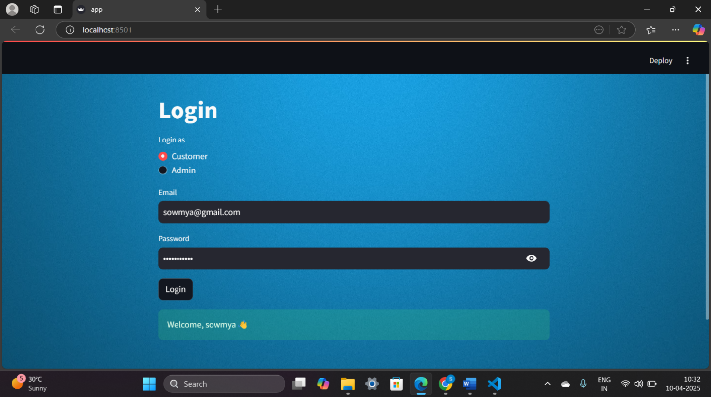

**Figure- 6.2: Green success message**

The above Figure- 6.2 shows a login page where the user has selected "Customer" and entered valid credentials. Upon clicking the **Login** button, a green success message — **"Welcome, sowmya 👋"** — is displayed. This confirms that the email and password are correct. The interface is clean, with role selection and secure password entry.

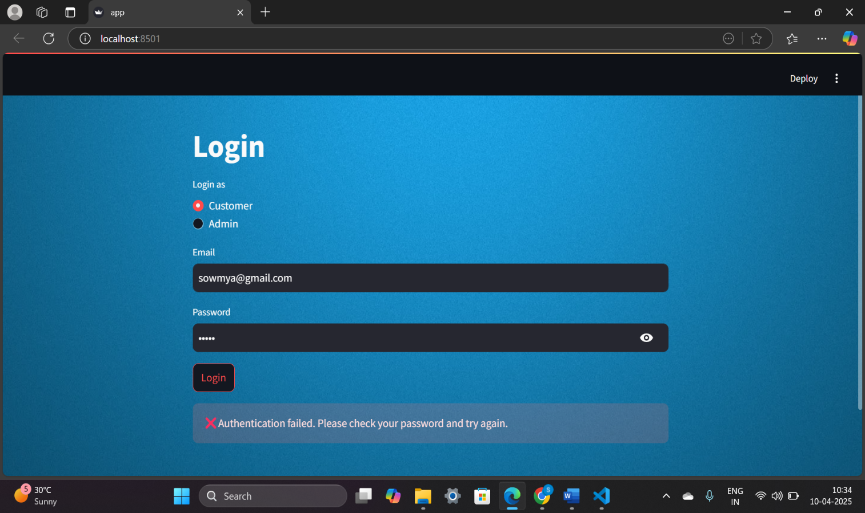

**Figure- 6.3: Authentication failed**

The above Figure- 6.3 indicates a warning that will be displayed during login, when a user uses a wrong password. The user must login only with registered email id and password.

|  |  |  |
| --- | --- | --- |
| **Input** | **Output** | **Result** |
| Input | Tested for different inputs given by users. | Success |
| Model | Tested for different inputs given by the user on seven models (Logistic Regression, K-Nearest Neighbors (KNN), Decision Tree, Random Forest, XGBoost, Support Vector Machine (SVM), and Neural Network), calculated and compared the performance metrics of three models and have chosen the best model (Random Forest). | Success |
| Prediction | Prediction is performed using the model | Success |

|  |  |  |  |  |  |
| --- | --- | --- | --- | --- | --- |
| **S.NO** | **Test cases** | **Input** | **Expected Output** | **Actual Output** | **Results** |
| 1 | Read the datasets. | Dataset path. | Dataset need to read successfully. | Dataset fetched successfully. | Success |
| 2 | Registration | Valid mobile number, password. | Verify that the registration form accepts valid user inputs and successfully creates a new account. | User is successfully registered, and an account is created | Success |
| 3 | Login | Valid username and password | Verify that users log in with valid credentials | User is successfully logged in and redirected to the dashboard | Success |
| 4 | Find out the transaction is fraudulent or not | Upload the transaction details | Transaction is fraudulent or not | The transaction is classified whether fraudulent or not and if fraudulent a notification was sent to the user | Success |

**Table 6.4: Test results**

**6.4 RESULTS**

To compare the efficiency of the proposed system numerous experiments were performed on Logistic Regression, K-Nearest Neighbors (KNN), Decision Tree, Random Forest, XGBoost, Support Vector Machine (SVM), and Neural Network. The three models were trained to identify fraudulent transactions in order to compare their efficiency when tested under similar circumstances.

**SHAP Result for Random Forest:**

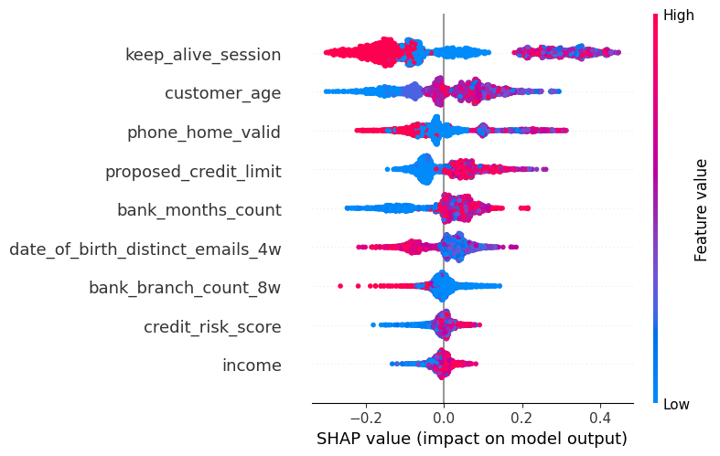

**Figure- 6.5: SHAP Result for Random Forest**

**SHAP Result for XGBoost:**

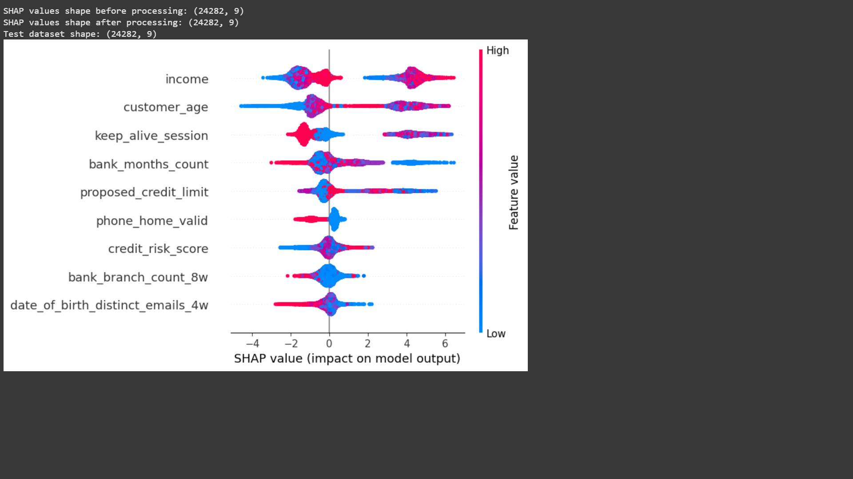

**Figure- 6.6: SHAP Result for XGBoost**

**SHAP Result for Logistic Regression:**



**Figure- 6.7: SHAP Result for Logistic Regression**

**Comparative Analysis:**

| **Metric** | **Random Forest** | **XGBoost** | **Logistic Regression** | **KNN** | **Decision Tree** | **SVM** | **Neural Network** |
| --- | --- | --- | --- | --- | --- | --- | --- |
| Precision | 99% | 97% | 98.5% | 97.3% | 98.9% | 96% | 98% |
| Recall | 99% | 88.6% | 89.2% | 90% | 91% | 96% | 93% |
| Accuracy | 99.1% | 99.2% | 99% | 94% | 96% | 95% | 94% |

**Table- 6.8: Comparative analysis**

The experimental results demonstrate that Logistic Regression, K-Nearest Neighbors (KNN), Decision Tree, Random Forest, XGBoost, Support Vector Machine (SVM), and Neural Network are all effective models for predicting financial fraud. Each algorithm offers distinct advantages based on the complexity and nature of the dataset.

Random Forest achieves high precision, recall, and overall accuracy, making it highly suitable for real-time fraud detection. XGBoost, with its boosting mechanism, delivers excellent accuracy and is particularly effective in handling complex fraud scenarios. Similarly, Neural Networks and SVM exhibit strong performance in learning non-linear patterns, while Logistic Regression and KNN provide competitive results with the added benefit of interpretability and simplicity.

Among all models, Random Forest and XGBoost stand out for their balanced performance across all evaluation metrics — precision, recall, and accuracy. According to the comparative analysis, XGBoost demonstrates slightly higher accuracy in complex conditions, whereas Random Forest is more consistent and reliable in real-time detection environments. Overall, ensemble-based methods like Random Forest and XGBoost show superior capabilities in detecting financial fraud with high accuracy and robustness.

1. **CONCLUSION**

**7. CONCLUSION**

The Real-Time Fraud Detection platform for credit card transactions offers a comprehensive and secure solution for managing and monitoring financial transactions. Utilizing machine learning techniques. These models are trained to analyze transaction data and pinpoint any suspicious activity, providing an automated safeguard for users engaged in financial exchanges. The platform relies on PostgreSQL for data management, while streamlit aids in seamless web app development, with python optimizing performance using modern web development methodologies. Moreover, the platform emphasizes user security by implementing robust authentication processes to protect personal and financial information from unauthorized access. By analyzing past transaction logs, the platform increases the accuracy of fraud detection, ensuring that new transactions are evaluated within the context of previous ones. This adaptive approach is crucial for identifying new or previously unknown fraudulent methods, allowing the platform to swiftly mitigate any potential risks.

Additionally, the system strengthens security by automatically halting transactions flagged as fraudulent, effectively minimizing financial losses. The platform also includes a transparent transaction history feature, empowering users to review and verify their financial activities. This enhances trust and provides users with greater control over their transactions. With its user-friendly design and dependable fraud detection capabilities, the platform. In conclusion, this platform merges secure transaction processing with cutting-edge fraud detection technologies, offering users a seamless and protected method for transferring funds.

Furthermore, integrating distributed ledger technology, such as blockchain, could strengthen the transparency and immutability of transaction data, fostering trust and accountability among users and service providers. Expanding the fraud detection capabilities of the system is another important area for improvement. Currently, the platform detects fraud based solely on transaction data. Future versions could incorporate additional data sources, such as user behavior analytics, device fingerprinting, and biometric verification (e.g., facial recognition or fingerprint scanning), for stronger authentication and better fraud prevention.

1. **BIBLIOGRAPHY**

**8. BIBLIOGRAPHY**

1. [1] Bhagirath, Mittal, N., & Kumar, S. (2023). Impact of Real Time Fraud Prevention on Online Resale Platform using Machine Learning and Device Fingerprint Techniques. *International Journal of Performability Engineering*, *19*(2), 94. <https://doi.org/10.23940/IJPE.23.02.P2.94104>
2. [2] Chen, L. C., Hsu, C. L., Lo, N. W., Yeh, K. H., & Lin, P. H. (2017). Fraud analysis and detection for real-time messaging communications on social networks. *IEICE Transactions on Information and Systems*, *E100D*(10), 2267–2274. <https://doi.org/10.1587/TRANSINF.2016INI0003>
3. [3] Chumuang, N., Hiranchan, S., Ketcham, M., Yimyam, W., Pramkeaw, P., & Tangwannawit, S. (2020). Developed Credit Card Fraud Detection Alert Systems via Notification of LINE Application. *Proceedings - 2020 15th International Joint Symposium on Artificial Intelligence and Natural Language Processing, ISAI-NLP 2020*. <https://doi.org/10.1109/ISAI-NLP51646.2020.9376829>
4. [4] Min, M., Lee, J. J., Park, H., & Lee, K. (2021). Detecting Anomalous Transactions via an IoT Based Application: A Machine Learning Approach for Horse Racing Betting. *Sensors 2021, Vol. 21, Page 2039*, *21*(6), 2039. <https://doi.org/10.3390/S21062039>
5. [5] Sun, L., Cao, B., Wang, J., Srisa-An, W., Yu, P. S., Leow, A. D., & Checkoway, S. (2021). Kollector: Detecting Fraudulent Activities on Mobile Devices Using Deep Learning. *IEEE Transactions on Mobile Computing*, *20*(4), 1465–1476. <https://doi.org/10.1109/TMC.2020.2964226>
6. [6] Yeh, K. H., Lo, N. W., Chen, L. C., & Lin, P. H. (2016). A fraud detection system for real-time messaging communication on Facebook messenger. *2015 IEEE 4th Global Conference on Consumer Electronics, GCCE 2015*, 361–363. <https://doi.org/10.1109/GCCE.2015.7398737>
7. K. S. Ling, D. K. A. Yau, and H. L. Fu, “Differential Privacy in Financial Data Analysis for Fraud Detection,” *Journal of Computer Science and Technology*, vol. 34, no. 2, pp. 112-125, Mar. 2019, doi: 10.1007/s11390-019-1900-4.
8. Chen Zhang, Wei Liu, and Yan Liu, “A Transparent and Privacy-Preserving Approach to Fraud Detection Using Deep Learning,” *International Journal of Computer Vision and Image Processing*, vol. 13, no. 3, pp. 203-215, Jul. 2021, doi: 10.1016/j.ijcvip.2021.03.010.
9. O. M. K. Kwon and S. S. Lee, “Blockchain and Smart Contracts for Financial Fraud Detection,” *Journal of Blockchain Technology and Applications*, vol. 12, no. 4, pp. 76-89, Nov. 2019, doi: 10.1177/2393979619861234.
10. Y. He, J. Xu, and J. Huang, “Secure and Private Machine Learning for Financial Fraud Detection,” *IEEE Transactions on Secure and Privacy Issues in Computing*, vol. 24, no. 3, pp. 389-401, Sep. 2018, doi: 10.1109/TSPIC.2018.2839423.
11. L. G. Vicente, F. D. Júnior, and S. Oliveira, “Transparent and Accountable Artificial Intelligence for Fraud Detection in the Financial Sector,” *Journal of Artificial Intelligence Research*, vol. 51, no. 2, pp. 105-118, Feb. 2020, doi: 10.1613/jair.5049.
12. T. S. Fernandes and M. G. Rodrigues, “Privacy-Preserving Algorithms for Financial Fraud Detection: A Comparative Study,” *Journal of Privacy and Security Technologies*, vol. 6, no. 1, pp. 44-59, Jan. 2021, doi: 10.1002/pts.1762.
13. C. J. Tan and R. H. M. D. Guzman, “Privacy in Financial Fraud Detection: Balancing Model Accuracy and User Privacy,” *Journal of Financial Privacy and Security*, vol. 8, no. 2, pp. 153-169, Mar. 2019, doi: 10.1109/JFP.2019.0848592.

1. **APPENDIX**

**9. APPENDIX**

**9.1 Project Repository Details**

**Project Title:** Transparency in Financial Fraud Detection Using Explainable AI

**Batch:** B3

**Batch Members:** 1.KOMMULA LAKSHMI DEEKSHITA -21B01A0581

2.KARANAM SATYA VENKATA MANI SOWMYA -21B01A0571

3.LALITHA SRI CHALAMALASETTI -21B01A0589

4.MALLIPUDI LAKSHMI PRASANTHI -21B01A0594

5.NALLURI SAMHITHA -21B01A05B6

**Department:** Computer Science and Engineering

**Institution:** Shri Vishnu Engineering College for Women

**Guide:** Dr. V. Purushothama Raju

**Submission Date:** 12/04/2025

**Project Repository Link:**

The complete project files, including source code, documentation, and additional resources, are available at the following GitHub repository:

**GitHub Repository:**

<https://github.com/lalithasrich/Transparency_in_Finanancial_fraud_detectio_using_explainable_AI>

**For quick access, scan the QR code below:**

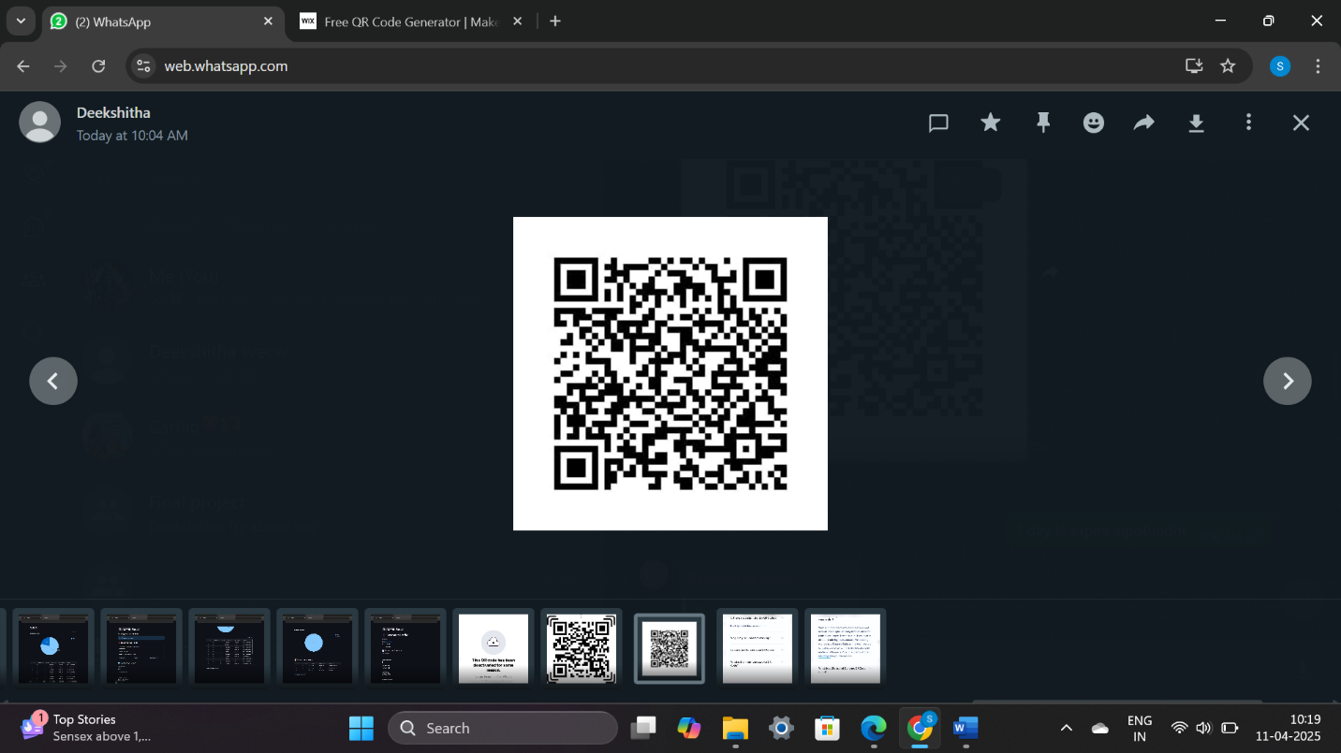

**9.2 INTRODUCTION TO PYTHON PROGRAMMING**

Python is a powerful multi-purpose programming language created by Guido van Rossum. It has simple easy-to-use syntax, making it the perfect language for someone trying to learn computer programming for the first time. This is a comprehensive guide on how to get started in Python, why you should learn it and how you can learn it. However, if you know other programming languages and want to quickly get started with Python. Python is a general-purpose language. It has a wide range of applications from Web development, scientific and mathematical computing to desktop graphical user Interfaces. The syntax of the language is clean and the length of the code is relatively short. It is fun to work in Python because it allows you to think about the problem rather than focusing on the syntax.

Python was selected as the primary programming language for this project due to several compelling reasons. Firstly, Python's extensive standard library and third-party packages provide a rich set of tools for various tasks, ranging from web development to data analysis and machine learning. Additionally, its dynamic typing and high-level abstractions enable rapid prototyping and development, essential for meeting project deadlines and iterating on solutions. Furthermore, Python's community driven development model ensures continuous improvement and innovation, with a vast array of resources available for learning and troubleshooting. Whether it's through online forums, tutorials, or official documentation, Python's supportive ecosystem empowers developers to overcome challenges and unlock new possibilities.

**Features of Python Programming**:

Python is renowned for its simplicity, readability, and versatility, making it a popular choice for a wide range of applications. Below are some of the key features that contribute to Python's appeal and effectiveness as a programming language.

**1. Clear and Readable Syntax:** Python's syntax is designed to be clear, concise, and easily understandable. This readability not only facilitates easier code maintenance but also enhances collaboration among developers.

**2.** **Interpreted and Interactive:** Python is an interpreted language, meaning that code execution occurs line by line, which enables rapid prototyping and debugging. Additionally, Python supports interactive mode, allowing users to execute code interactively and explore features dynamically.

**3. Dynamic Typing:** Python is dynamically typed, meaning that variable types are inferred at runtime. This flexibility eliminates the need for explicit type declarations, simplifying code writing and promoting code reusability.

**4. High-level Abstractions:** Python offers high-level abstractions such as list comprehensions, lambda functions, and object-oriented programming constructs. These features enable developers to express complex ideas in a concise and expressive manner.

**5. Extensive Standard Library:** Python comes with a comprehensive standard library that provides ready-to-use modules and functions for various tasks, ranging from file I/O and networking to data manipulation and web development. This rich library ecosystem accelerates development and minimizes the need for external dependencies.

**6. Third-party Libraries and Frameworks:** In addition to its standard library, Python boasts a vast ecosystem of third-party libraries and frameworks catering to specialized domains such as data science, web development, machine learning, and more. Popular libraries like NumPy, pandas, TensorFlow, Torch, Flask etc., extend Python's capabilities and empower developers to tackle diverse challenges.

**7. Cross-platform Compatibility:** Python is platform-independent, meaning that Python code can run seamlessly on different operating systems, including Windows, macOS, and Linux. This portability makes Python an ideal choice for developing cross-platform applications.

**8. Community Support and Documentation:** Python has a large and active community of developers who contribute to its ongoing development and maintenance. This community support is reflected in extensive documentation, online forums, and tutorials, providing valuable resources for learning and troubleshooting.

**9. Ease of Integration:** Python seamlessly integrates with other programming languages and technologies, allowing developers to leverage existing code and infrastructure. Whether interfacing with C/C++, Java, or .NET, Python offers robust support for interoperability and integration.

**10. Scalability and Performance:** While Python is often praised for its ease of use and productivity, it also offers scalability and performance when optimized correctly. Techniques such as code profiling, concurrency, and leveraging compiled extensions can significantly enhance Python's performance in resource-intensive applications.

**Python Libraries:**

Python libraries are collections of modules that provide reusable code for various functionalities, reducing development time. They cover areas like data analysis (pandas, numpy), machine learning (scikit-learn, tensorflow), web development (flask, django), and more. These libraries enhance Python's capabilities, making it versatile for different applications.

The libraries that we have used in this project are:

**Flask:**

* Flask is a lightweight and flexible web framework for Python.
* It follows the WSGI standard and allows rapid development of web applications.
* Flask provides built-in support for routing, templates, and request handling.
* It is extensible, allowing integration with databases, authentication, and middleware.
* Suitable for small to medium-sized applications, including APIs and microservices.

**Torch (PyTorch):**

* PyTorch is an open-source deep learning framework based on the Torch library.
* It offers dynamic computation graphs, making model building more intuitive.
* Supports GPU acceleration for efficient large-scale computations.
* Commonly used for computer vision, NLP, and reinforcement learning tasks.
* Provides extensive libraries like torchvision and torchtext for specialized tasks.

**TensorFlow:**

* TensorFlow is a powerful machine learning framework developed by Google.
* It provides tools for building, training, and deploying AI models at scale.
* Supports both static (TensorFlow 1.x) and dynamic (TensorFlow 2.x) computation graphs.
* Works efficiently on CPUs, GPUs, and TPUs for high-performance training.
* Offers Keras as a high-level API for easier deep learning model development.

**Pandas:**

* Pandas is a Python library for data manipulation and analysis.
* It provides data structures like DataFrames and Series for handling tabular data.
* Offers functions for data cleaning, transformation, and aggregation.
* Supports data import/export from multiple sources like CSV, Excel, and SQL databases.
* Widely used in data science, finance, and machine learning applications.

**mysql.connector:**

* mysql.connector is a Python library for connecting to MySQL databases.
* It allows executing SQL queries and managing database interactions.
* Supports both synchronous and asynchronous operations.
* Provides secure authentication and transaction management features.
* Useful for integrating MySQL with Python applications for data storage and retrieval.

**Workbench:**

The workbench we have used in this project is Android Studio and Jupyter Notebook.

**Streamlit:**

Streamlit is an open-source Python framework specifically designed for creating and deploying data-driven web applications with ease. It allows developers and data scientists to build interactive web apps directly from Python scripts, making it an ideal choice for integrating machine learning models and visualizations into user-friendly interfaces.

* **Language & Integration:** Supports Python and integrates with ML libraries like scikit-learn, TensorFlow, PyTorch, Pandas, and Plotly.
* **Features**: Provides built-in widgets (sliders, buttons, forms, file uploads) for building interactive UIs easily.
* **Customization**: Supports layout customization using themes, columns, sidebars, and containers.
* **Cross-Platform**: Runs on any OS with Python and can be deployed via Streamlit Cloud, Heroku, or AWS.

**Jupyter Notebook**:

Jupyter Notebook is an open-source web application that allows you to create and share documents containing live code, equations, visualizations, and narrative text. It is widely used for data science, machine learning, scientific computing, and educational purposes. It supports interactive data exploration and prototyping, making it a powerful tool for various analytical tasks.

* **Languages & Extensions**: Jupyter Notebook supports multiple programming languages such as Python, R, Julia, and more. It can also be extended with kernels for additional languages and integrations with various data science libraries like NumPy, Pandas, Matplotlib, TensorFlow, and others.
* **Features**: Jupyter Notebook provides features like interactive coding with real-time output display. Visualization support for creating charts, graphs, and plots. Markdown support for adding formatted text, equations, and annotations alongside code. Export options to export notebooks to formats like HTML, PDF, and slides.
* **Customization**: Jupyter Notebook allows some level of customization through extensions and themes, such as interactive widgets for dynamic content. Customizable notebooks for personalized layout and styles using Jupyter themes and Nbextensions.
* **Cross-Platform**: Jupyter Notebook is available for Windows, macOS, and Linux, allowing for a consistent experience across different operating systems. It is typically run through a browser, providing platform independence.

**9.3 STREAMLIT:**

Client-side rendering (CSR), also known as front-end development, is a modern approach in app development where the client (the mobile device or browser) is responsible for rendering and displaying the user interface. In this approach, the server only provides the raw data or APIs, while the rendering logic is handled on the client-side. In our web application, Kotlin is used for implementing the front-end by leveraging streamlit native UI components and libraries. Client-side rendering (CSR) is used in this project, where the user interface is rendered in the browser, and only data is fetched from the server. We utilize Streamlit to create and manage the UI, user interactions, and app logic using Python.

**UI Design:**

* **Streamlit Components:** Uses built-in components like st.button, st.text_input, st.selectbox, st.file_uploader, etc., to design interactive interfaces.
* **Custom Layouts**: Layout is managed using columns, containers, sidebars, and expanders for responsive design and better user flow.
* **Theming**: Streamlit allows custom theming via config.toml to match branding and improve visual appeal.

**UI Components & Views:**

* **Widgets**: Python functions manage interactive widgets for input/output such as text fields, buttons, sliders, charts, and media elements.
* **Display Tools**: Uses st.write(), st.markdown(), st.dataframe(), and st.plotly_chart() to display content dynamically.
* **Material Style**: Though Streamlit doesn’t use native Material Design, UI principles like cards and hierarchy are replicated using container-based layouts.

**Layouts:**

* **Column/Grid System**: Streamlit supports layout division with st.columns() and st.container() for organized, responsive designs.
* **Sidebar Navigation**: st.sidebar is used to hold filters, navigation controls, or user preferences.

**Navigation:**

* **Session State**: Navigation and dynamic screen transitions are handled using st.session_state, which manages screen/page switching.
* **Multi-Page Apps**: Streamlit’s multipage structure (streamlit/pages/) helps in creating multi-view apps with logical separation.

**User Interactions:**

* **Event Handling**: Python functions and callbacks capture button clicks, form submissions, and input changes using simple if/else logic.
* **Form Validation**: Custom logic is used to validate and respond to user inputs in real-time.

**Animations & Transitions:**

* **Limited Animation**: While Streamlit doesn’t natively support complex animations, smooth user feedback can be simulated using loading spinners (st.spinner) and placeholder updates.

**Accessibility:**

* **Accessible Elements**: Streamlit components support keyboard navigation, screen readers, and basic accessibility standards.
* **Alt Text & Descriptions**: Images and charts can include alt text and descriptions for assistive technologies.

**9.4 PostgreSQL :**

In our application, the database used to store credentials such as name, email ID, and password during registration is **PostgreSQL**.

PostgreSQL is a powerful, open-source relational database management system (RDBMS) known for its reliability, feature-richness, and standards compliance. It is widely used in both small projects and large enterprise systems.

**Key Features of PostgreSQL:**

* **Relational Database**: Stores structured data in tables with rows and columns, supporting complex relationships using foreign keys and joins.
* **SQL-Based**: Uses standard SQL for defining, querying, and manipulating data.
* **ACID-Compliant**: Ensures data integrity with support for Atomicity, Consistency, Isolation, and Durability.
* **Extensibility**: Allows users to define their own data types, custom functions, and even write code in languages like Python or C.
* **JSON Support**: Offers advanced support for storing and querying JSON data, useful for semi-structured or API-driven applications.
* **Scalability**: Designed to handle everything from single-machine apps to large web-scale deployments.
* **Security**: Includes role-based access control, SSL encryption, and authentication methods for secure data handling.
* **Cross-Platform**: Compatible with Windows, macOS, and Linux environments.

**Working of PostgreSQL Notebook:**

* Install PostgreSQL from the official website based on your operating system.
* Set a username and password during installation for the default user.
* Start the PostgreSQL service after installation.
* Use the psql terminal or pgAdmin to interact with the database.
* Create a new database using the CREATE DATABASE command.
* Define tables using CREATE TABLE with appropriate columns and data types.
* Insert data using INSERT INTO statements.
* Retrieve data using SELECT queries.
* Update or delete records using UPDATE and DELETE commands.
* Connect PostgreSQL to applications using libraries like psycopg2 in Python.

**9.5 INTRODUCTION TO EXPLAINABLE AI:**

The project that we have worked on is an Explainable AI project. Explainable AI (XAI) is an area of artificial intelligence focused on making machine learning models, particularly deep learning models, more transparent and interpretable. While deep learning models often achieve high accuracy, they are often seen as "black boxes" due to their complex and opaque decision-making processes. XAI aims to bridge this gap by providing insights into how models make decisions and why they produce specific predictions.

Explainable AI techniques help to clarify the reasoning behind model outputs, making it easier for humans to understand, trust, and validate AI-driven decisions. Methods such as feature importance, model-agnostic explanations, and visualizations of decision boundaries are commonly used to interpret the inner workings of AI models.

In an explainable AI model, the goal is to enhance transparency without compromising performance. This allows stakeholders to identify biases, improve model fairness, and ensure that AI systems are operating in ways that are both accurate and ethical. 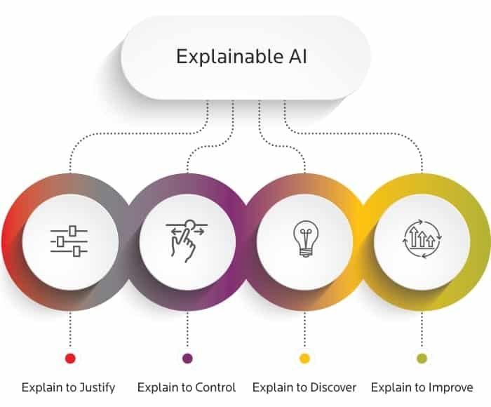

**Figure-9.1: Explainable AI**

**Working of Explainable AI:**

The working of Explainable AI (XAI) revolves around creating transparent machine learning models and providing human-understandable explanations for their predictions or decisions. Here's a general outline of how XAI works:

**Model Training:**

* **Train a machine learning model:** The process begins with training a machine learning model using large datasets. This model could be a deep neural network, decision tree, or any other machine learning model. In traditional AI, the model is treated as a black box with complex internal decision-making processes.

**Interpreting the Model:**

* **Generate explanations:** XAI techniques focus on providing insights into how the model makes predictions. These techniques either explain the model’s decision-making process directly (in the case of interpretable models) or use post-hoc methods to generate understandable insights after the model is trained.
* **Model-specific explanations:** In models that are inherently interpretable (e.g., decision trees), the structure of the model itself can be used to explain how inputs are mapped to outputs. For example, decision trees provide clear rules that can be understood by humans.
* **Model-agnostic explanations:** For more complex models (e.g., deep neural networks), post-hoc techniques like LIME or SHAP are used. These methods analyze how small changes in input data affect the model's predictions, helping to shed light on the model’s behavior.

**Explanations Generation Methods:**

* **Feature Importance:** This method ranks features (input variables) based on how influential they are in determining the model's predictions. For example, in a credit scoring model, feature importance might show that "annual income" and "credit history" have the most significant impact on the prediction.
* **Local Explanations:** Techniques like LIME provide explanations for individual predictions by approximating the model with a simpler, interpretable model locally around the input instance, helping users understand why a specific decision was made for a given input.
* **Global Explanations:** These explain the overall behavior of a model, offering insights into how the model behaves across all data points. Methods like partial dependence plots can show how a model’s predictions change when varying one feature at a time while keeping others constant.
* **Visualization:** In image-based models, techniques like Grad-CAM (Gradient-weighted Class Activation Mapping) highlight the regions of the image that contributed most to a prediction, making the decision-making process more transparent.

**Presenting the Explanation:**

* **User-friendly outputs:** The goal of XAI is to present the explanations in a format that is easy for humans to understand, whether through visual aids, summaries, or rule-based outputs. This helps users interpret and trust the model’s predictions, especially in critical applications like healthcare, finance, and law.

**Iteration and Model Refinement:**

* After providing an explanation, the insights can be used to refine the model.
* For instance, if the model is found to be making decisions based on biased or irrelevant features, the explanation can guide improvements in the data preprocessing or feature engineering steps.

**Human-AI Interaction:**

* The ultimate goal of XAI is to foster better human-AI collaboration. By providing transparent explanations, users can better understand, trust, and act on AI-driven decisions.
* This is especially important in high-stakes domains like healthcare, finance, and criminal justice, where AI's decision-making can have significant real-world consequences.

Explainable AI works by providing methods that help uncover and explain the inner workings of complex AI models, making them more transparent, interpretable, and trustworthy for human users.

**Advantages of Explainable AI:**

**Improved Trust and Transparency:**

* XAI helps build trust between humans and AI systems by providing clear, understandable reasons for predictions or decisions.
* This transparency is crucial for users to feel confident in relying on AI for critical tasks.

**Better Decision-Making:**

* With explainability, users can better understand how AI models make decisions.
* This allows them to make more informed decisions based on the model’s output, leading to better outcomes, especially in high-stakes areas like healthcare, finance, and criminal justice.

**Model Debugging and Improvement:**

* By explaining how models make decisions, XAI enables developers to identify potential issues like bias, overfitting, or incorrect feature importance.
* This can help improve the model’s performance and fairness by addressing these problems.

**Ethical AI Development:**

* XAI promotes fairness and accountability by making it easier to spot biases in models.
* By understanding how a model makes decisions, developers can ensure that the model is acting ethically and not reinforcing harmful stereotypes or discriminatory patterns.

**Enhanced User Experience:**

* Users can gain insights into the reasoning behind AI-driven recommendations or actions, which can lead to a better overall experience.
* For example, in customer support, XAI can explain why a chatbot gave a particular answer, improving user satisfaction.

**Fostering Collaboration between Humans and AI:**

* With clear explanations, humans can work alongside AI systems, understanding and interpreting the rationale behind AI’s decisions.
* This fosters a more collaborative relationship where humans can intervene or adjust the AI’s decisions when necessary.

**Increased Adoption of AI:**

* As AI systems become more understandable and trustworthy, industries and users are more likely to adopt AI technology.
* The ability to explain the model’s behavior makes AI more approachable and acceptable for various applications.

Explainable AI helps enhance the trust, performance, and ethical integrity of AI models, making them more practical and reliable for real-world applications.